**GARAGE MANAGEMENT SYSTEM**

College Name: Shree Venkateshwara Arts and Science (co-education) College, Gobi.

College Code: brubd

**TEAM ID:** NM2025TMID20883

**TEAM MEMBERS:**

**Team** **Leader Name:** Balamurugan.V

**Email:** [chandrukumar511983@gmail.com](mailto:chandrukumar511983@gmail.com)

**Team Member:** Santhiya.G

**Email:** [santhiyag2023cyber@gmail.com](mailto:santhiyag2023cyber@gmail.com)

**INTRODUCTION:**

A Garage Management System in Salesforce is designed to streamline automotive service operations, improve customer experience, and enhance efficiency. It leverages Salesforce’s CRM capabilities to manage appointments, vehicle records, billing, and inventory in one centralized platform. This system ensures workshops can track vehicles from check-in to delivery with full visibility. Customers benefit from timely updates, digital service history, and improved communication channels. With automated reminders, the system reduces missed appointments and boosts customer retention. Salesforce enables mechanics and managers to collaborate seamlessly with real-time data access. Parts inventory is tracked efficiently to prevent delays in service. Service advisors can generate accurate quotations and invoices instantly. Custom dashboards provide insights into revenue, workload, and customer satisfaction. Integration with mobile apps allows technicians to update job status directly from the workshop floor.

The system supports predictive maintenance through scheduled reminders and data analytics. Managers can track technician productivity and identify skill gaps. Integration with payment systems simplifies financial operations. Cloud-based access ensures anytime, anywhere management of workshop activities. Overall, the Garage Management System in Salesforce delivers a smart, customer-centric solution for modern automotive service centers.

**Salesforce:**

Salesforce is highly customizable with Service Cloud, Sales Cloud, Experience Cloud, and AppExchange apps.

Creating Developer Account:

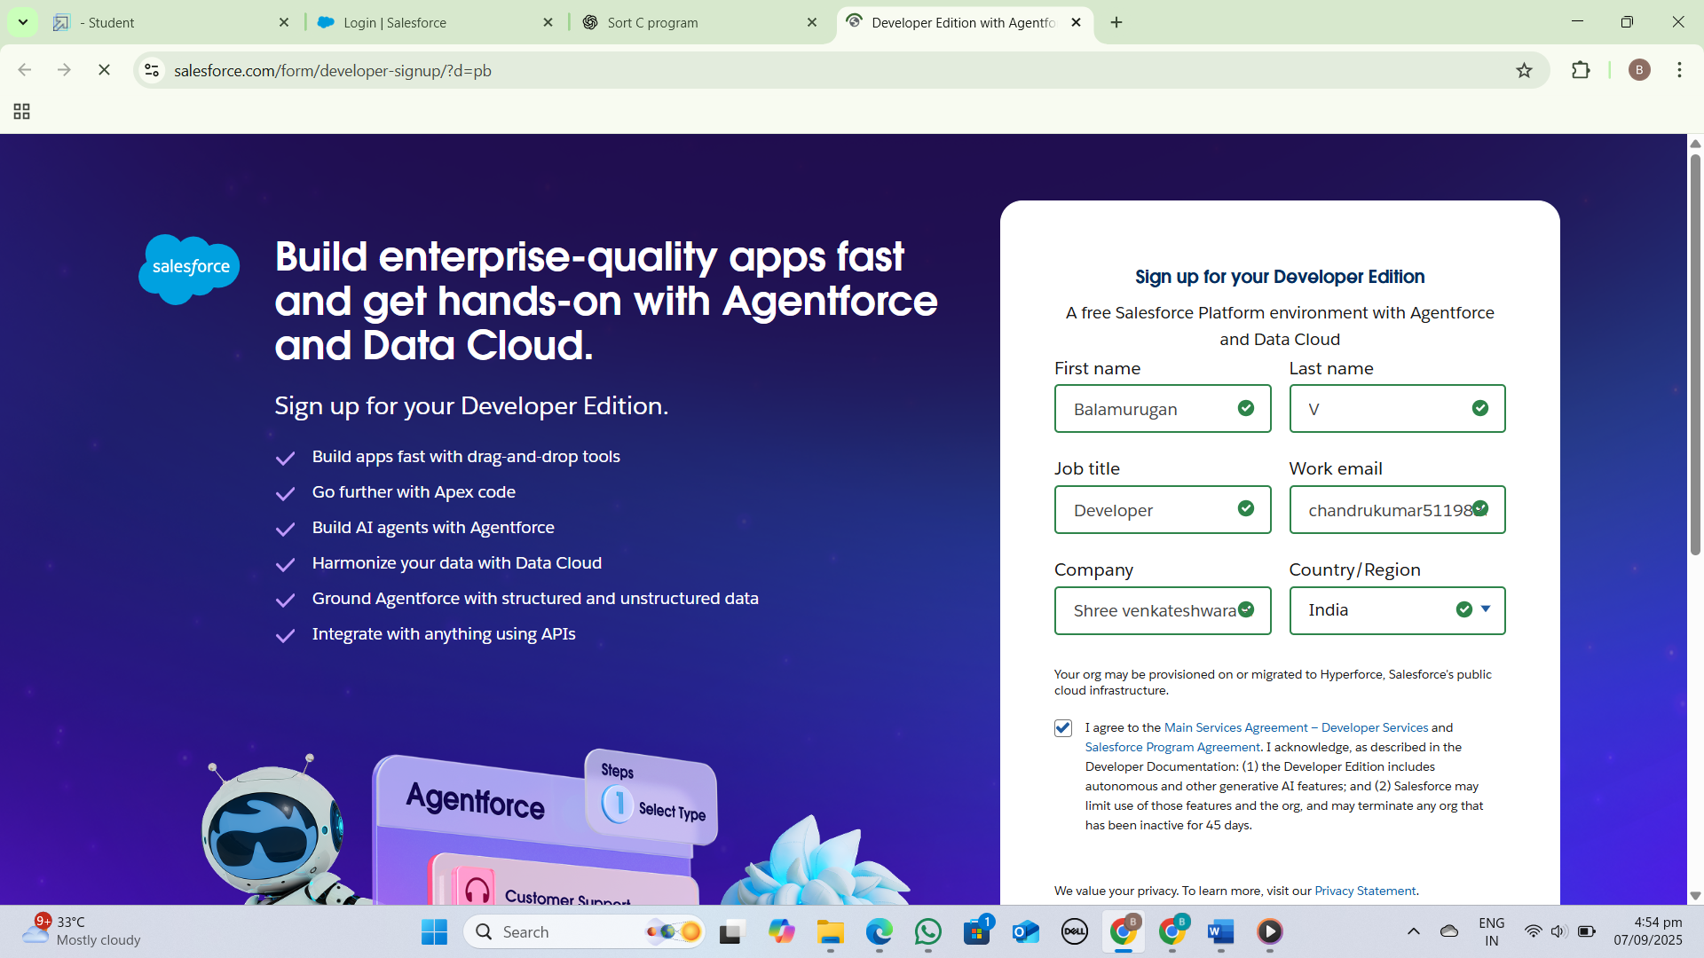

**Object:**

Manages vehicles, services, and appointments. *Vehicle* objects store vehicle details, *Service* objects define services offered, and *Appointment* objects schedule vehicle services. The system provides methods to add, view, and manage these objects efficiently.

Create Customer Details Object:

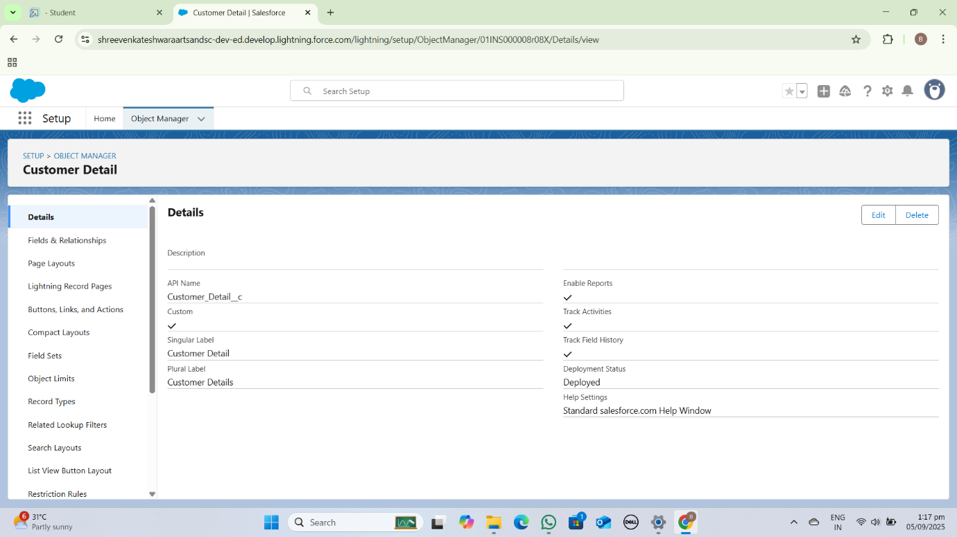

Create Appointment Object:

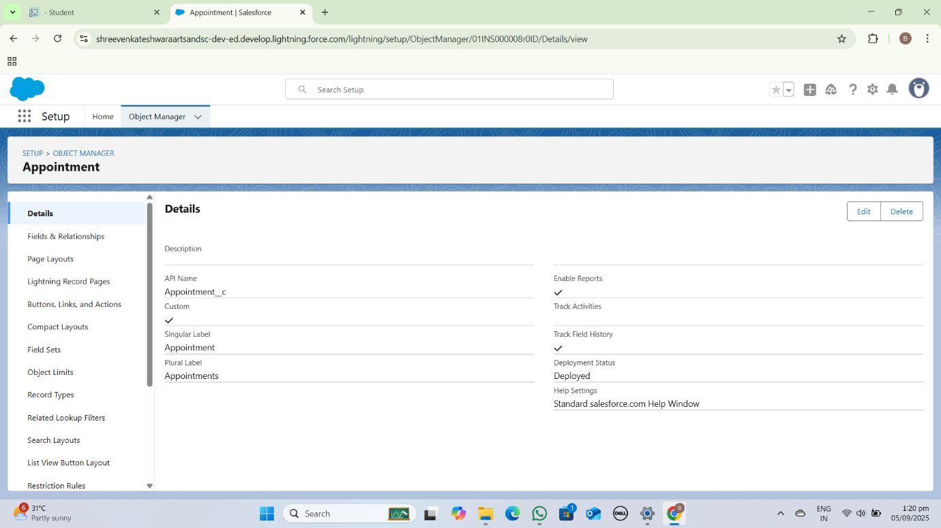

Create Service Record Object:

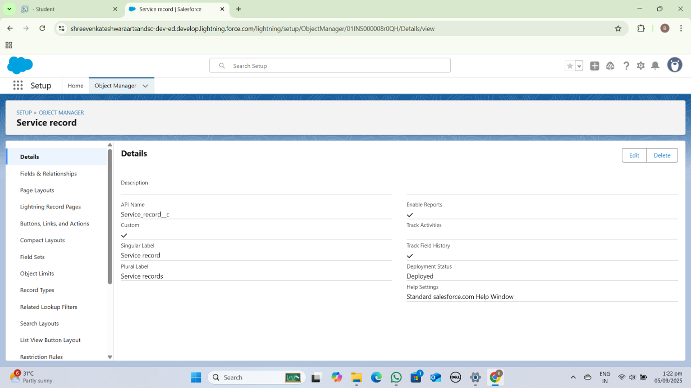

Create Billing Details and Feedback Object:

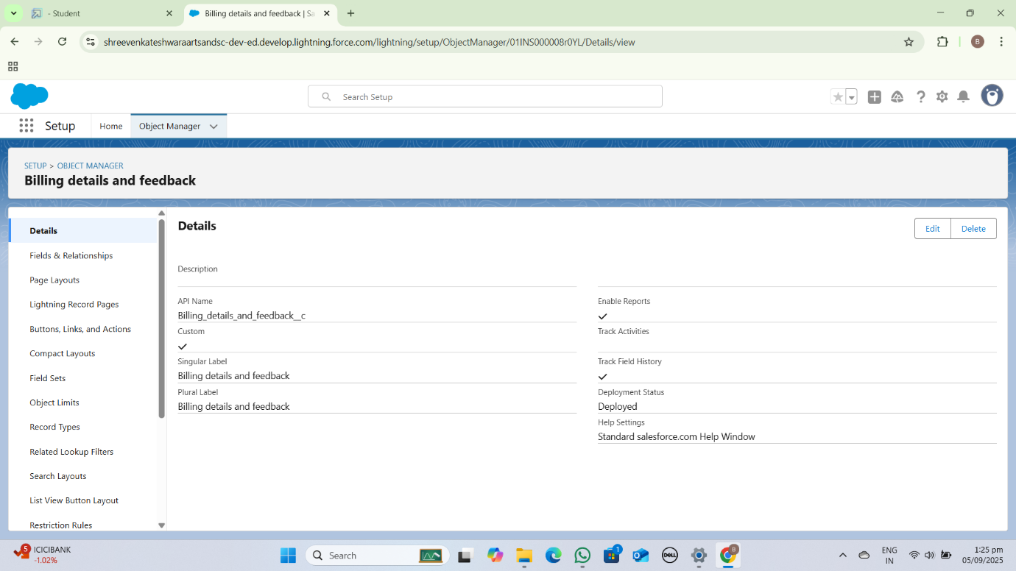

**Tabs:**

A Garage Management System (GMS) typically includes tabs for *Appointments*, *Customers*, *Vehicles*, and *Inventory*. These tabs organize system features and functions for easy access.

Creating A Custom Tabs:

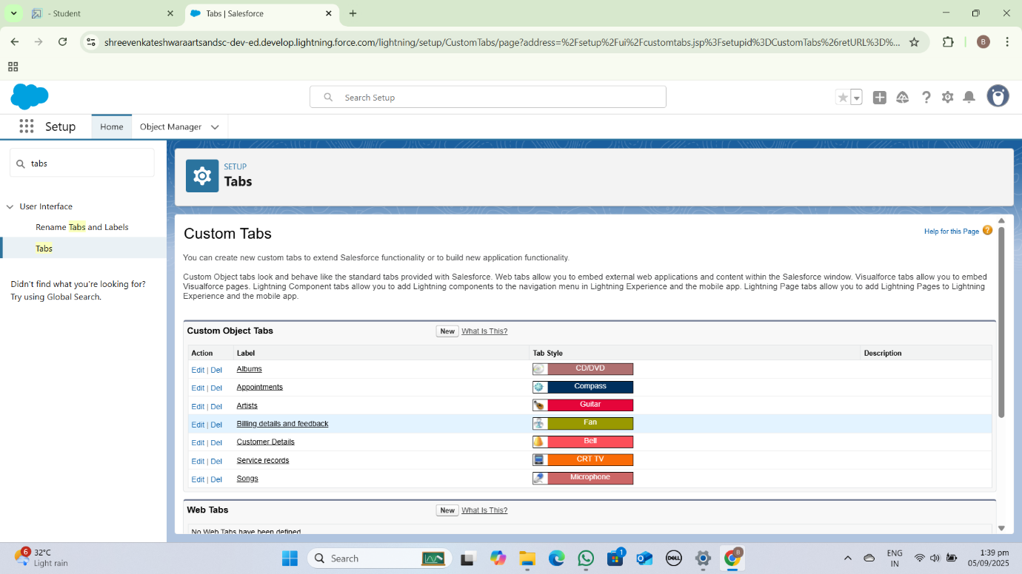

Create A Lighting App:

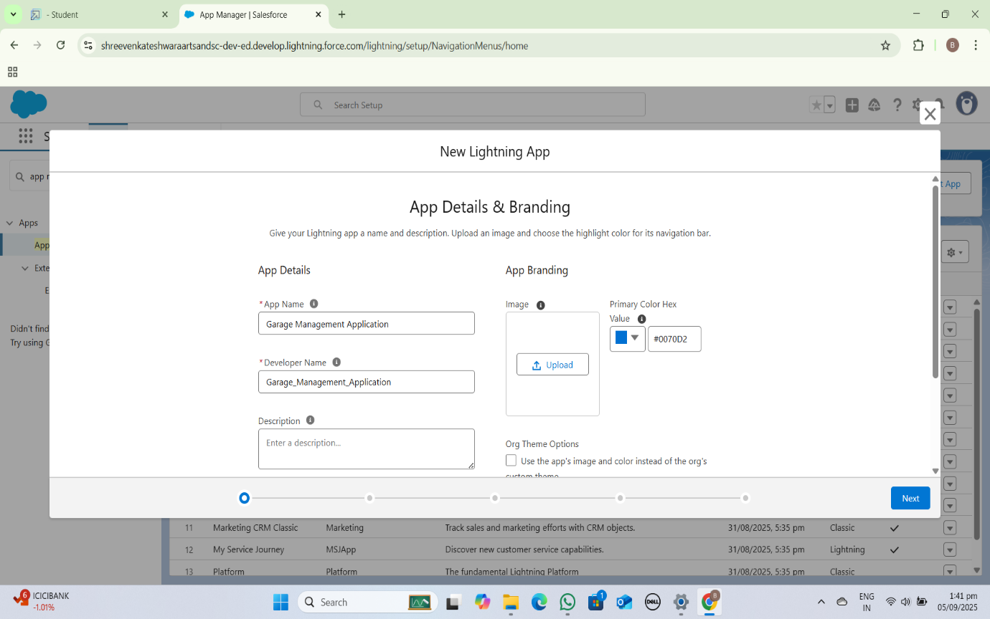

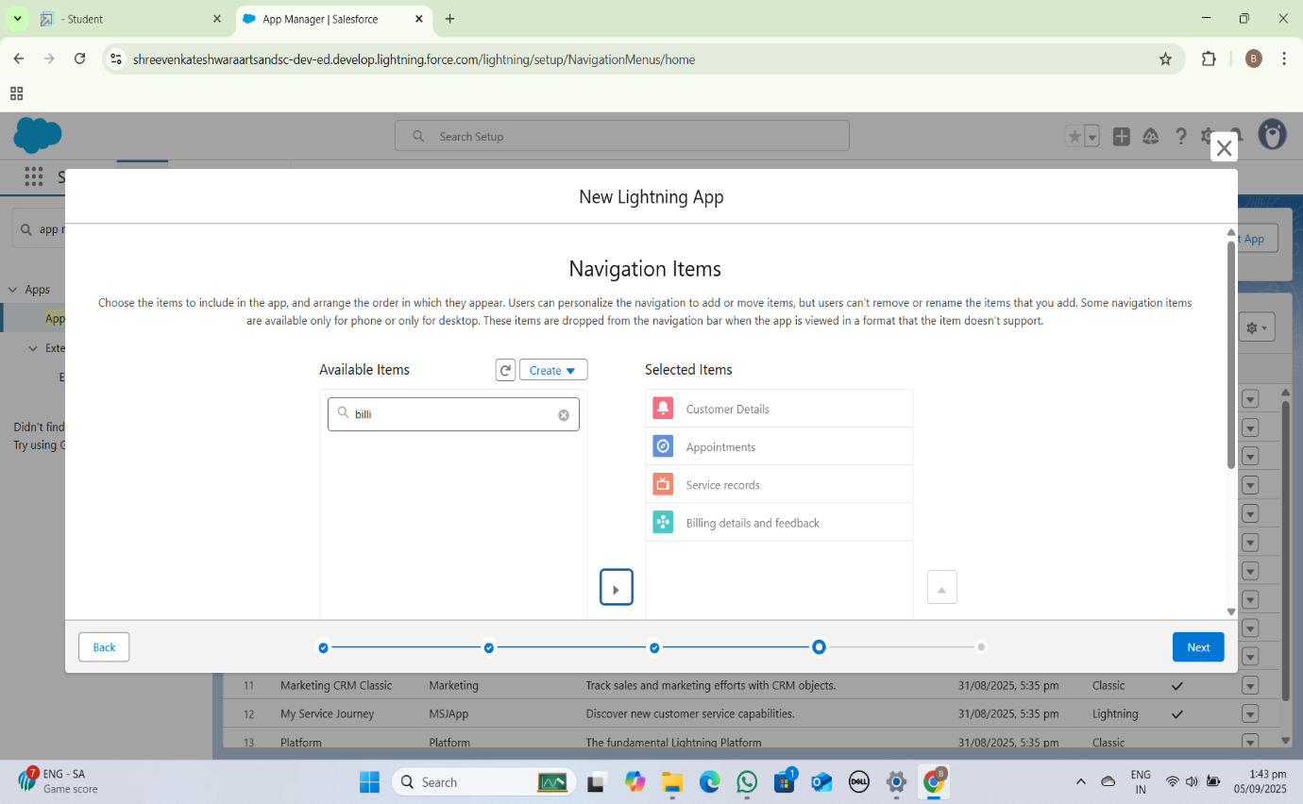

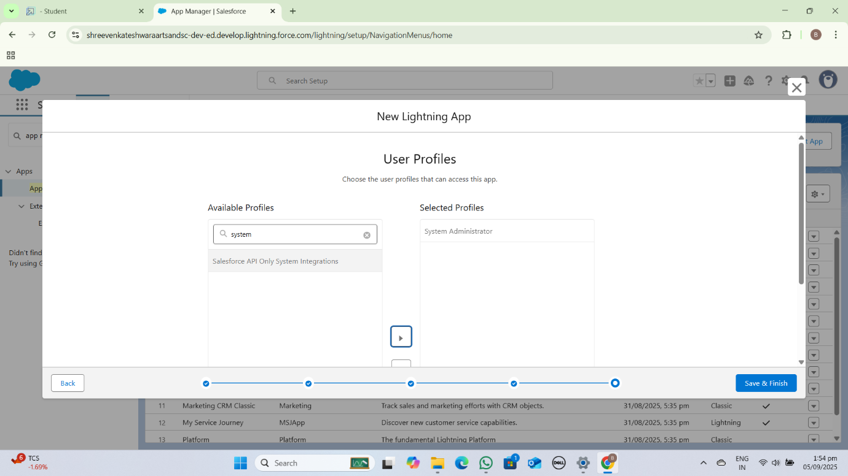

**Fields:**

1. *Vehicle Information*: Vehicle ID, customer name, vehicle type, license plate, etc.

2. *Service Details*: Service type, cost, description, etc.

3. *Customer Information*: Customer name, contact details, service history, etc.

4. *Payment and Billing*: Invoice numbers, payment status, amount, etc.

Creation Of Fields for The Customer Details Object:

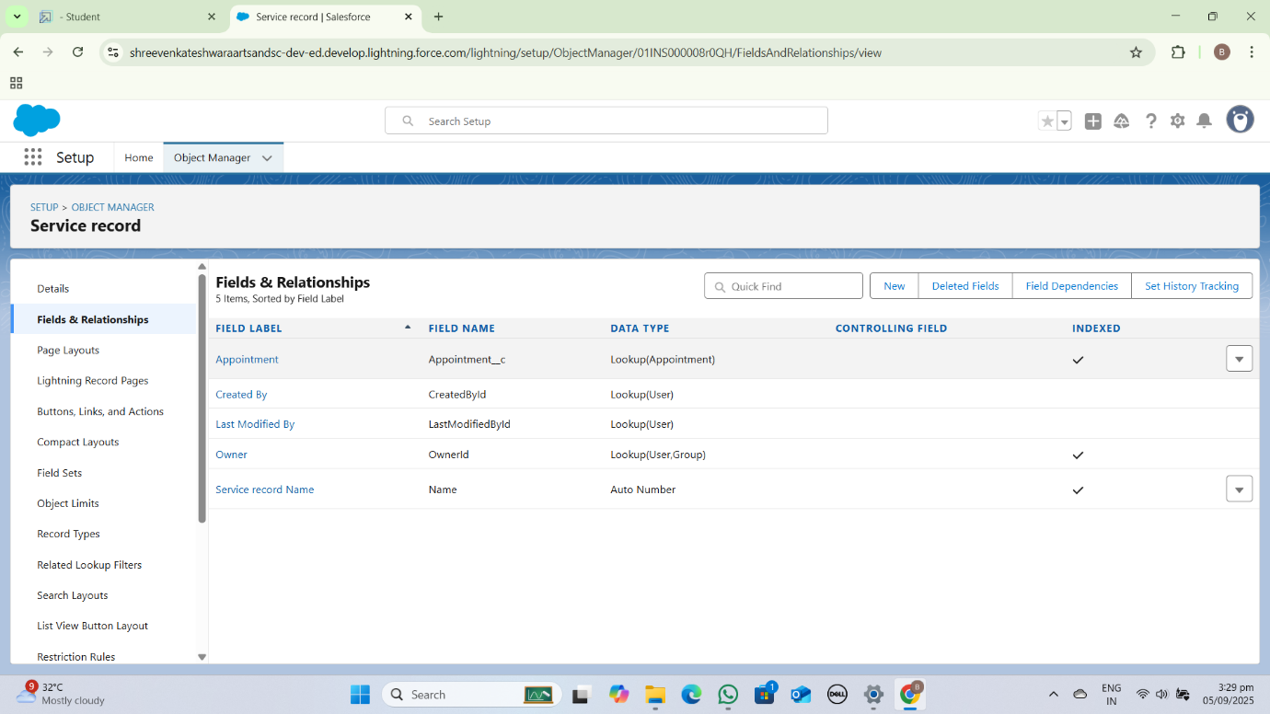

Creation Of Lookup Fields:

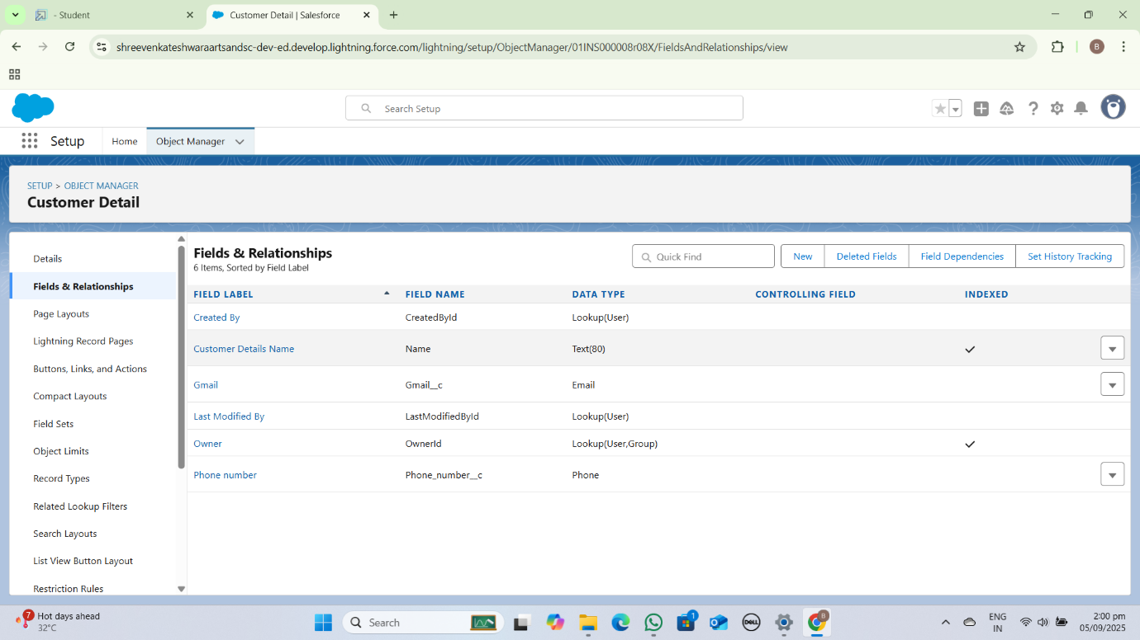

Creation Of Checkbox Fields:

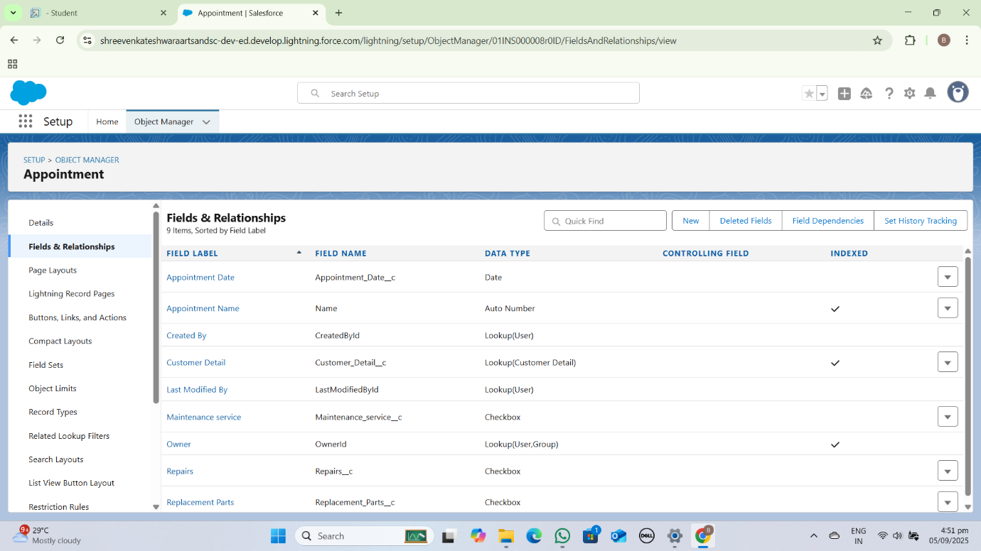

Creation Of Date Fields:

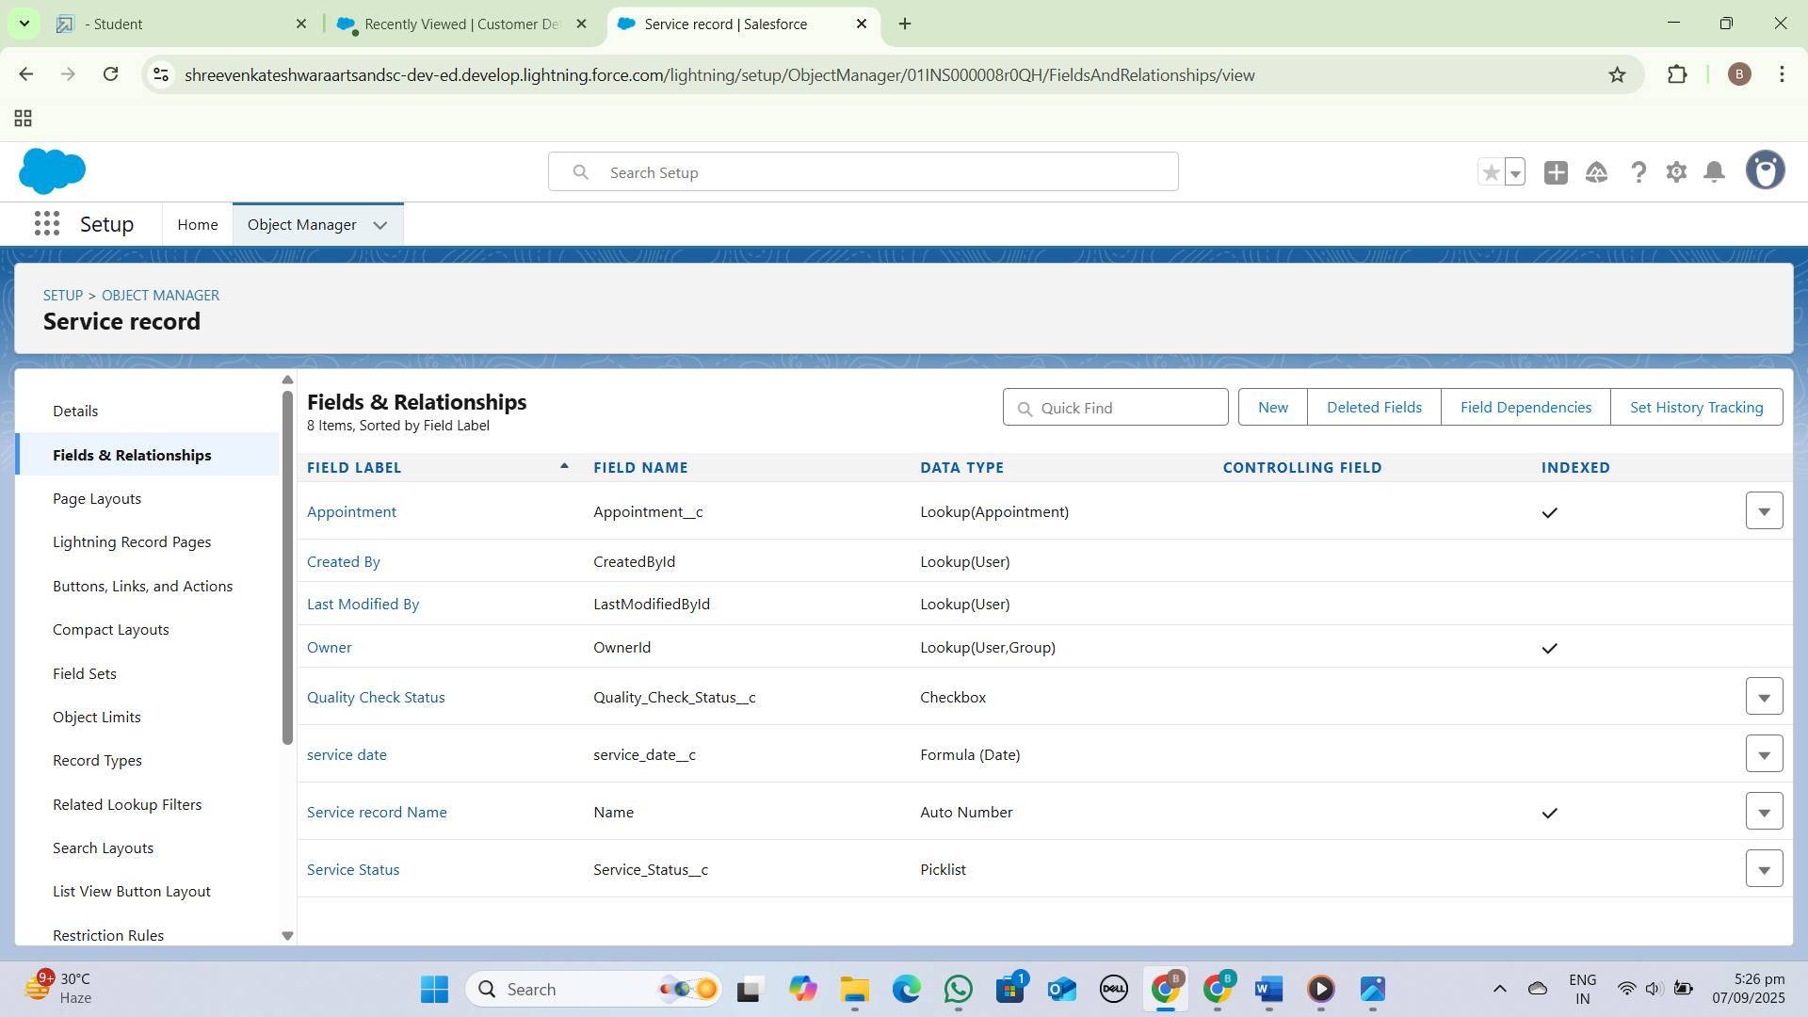

Creation Of Currency Fields:

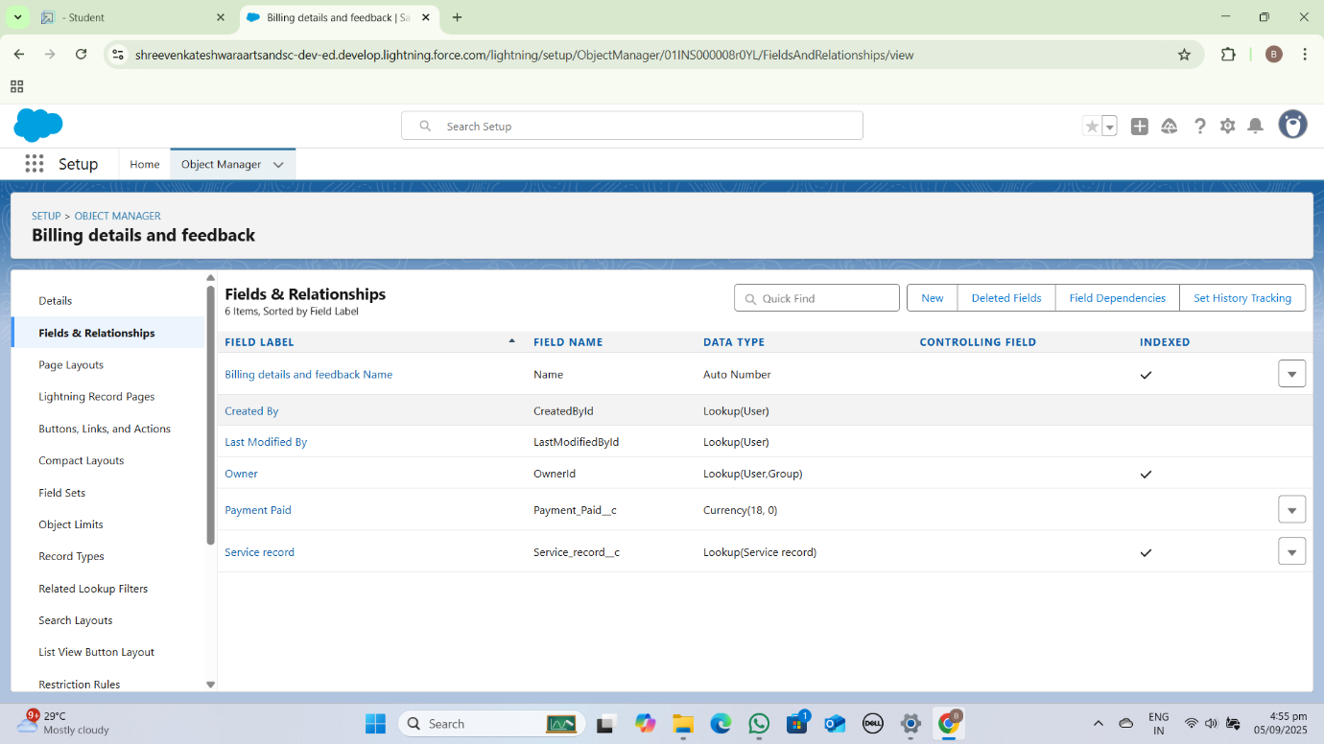

Creation Of Text Fields:

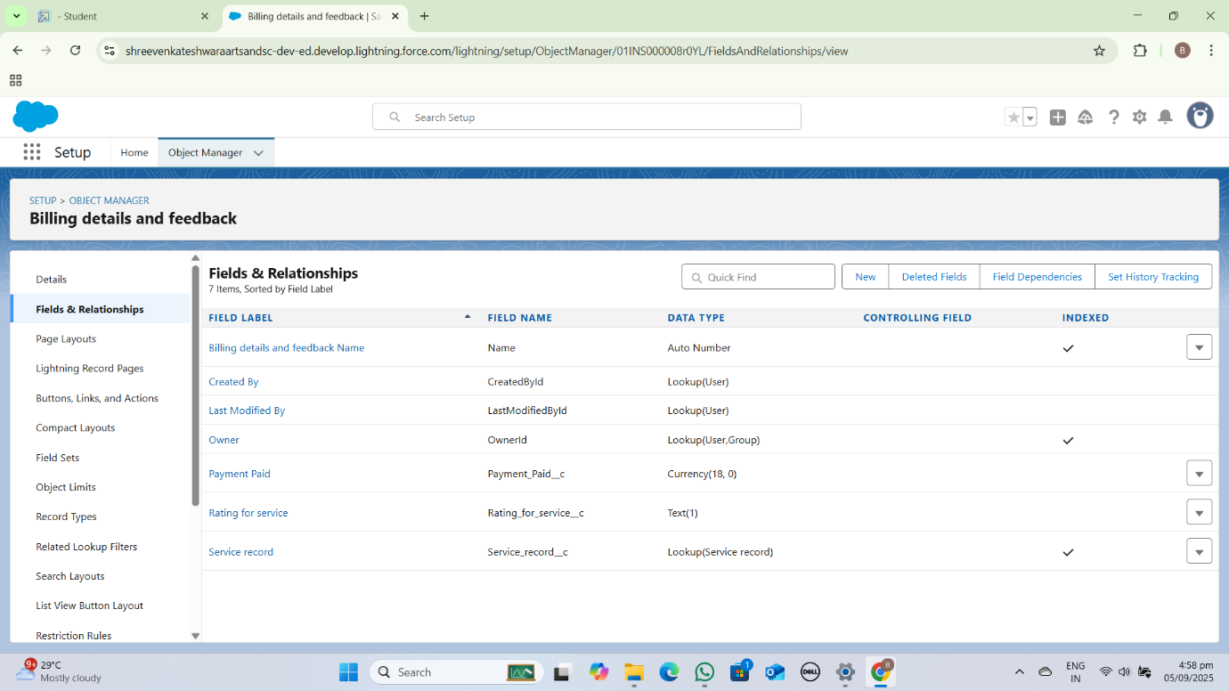

Creation Of Picklist Fields:

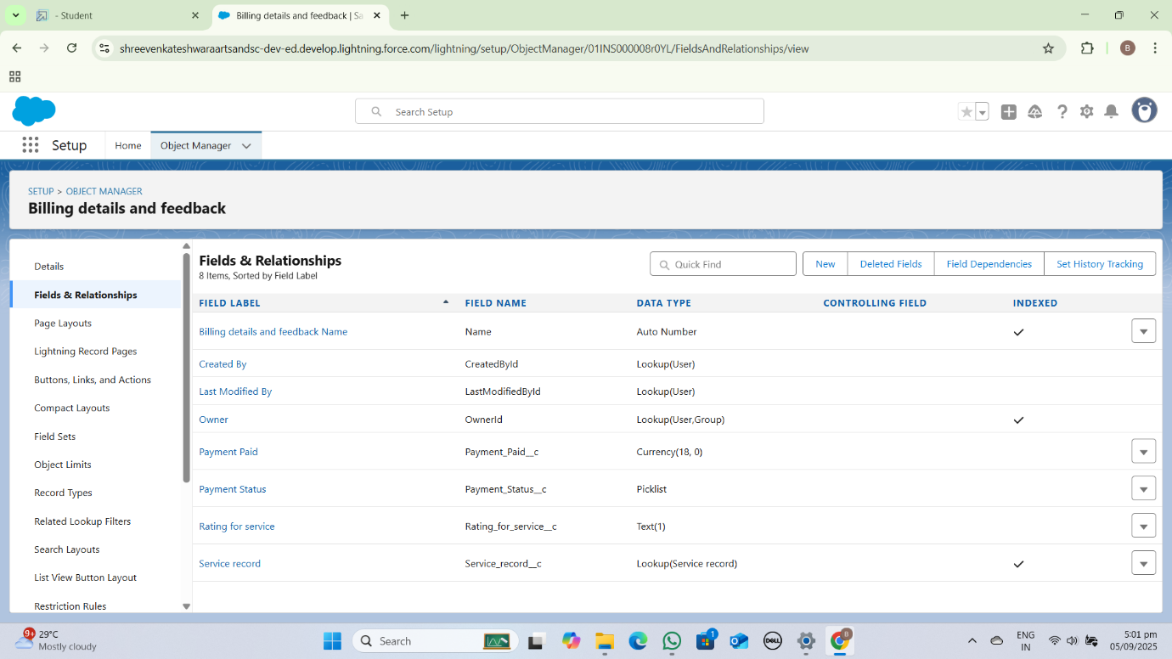

Creating Formula Field in Service Record Object:

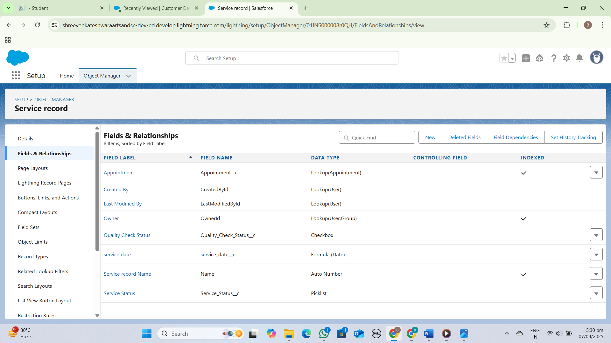

**Validation Rules:**

A Garage Management System (GMS) includes validation rules to ensure data accuracy and integrity, such as *Vehicle ID format*, *Service Date*, and *Payment Amount* validation. These rules prevent errors and inconsistencies in the system.

Rules:

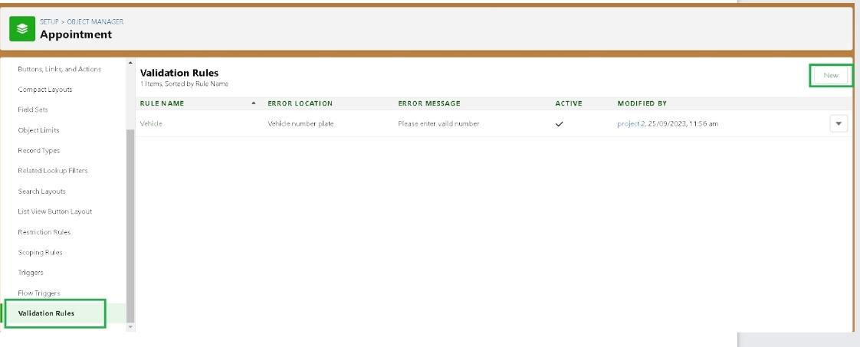

Condition As Formula:

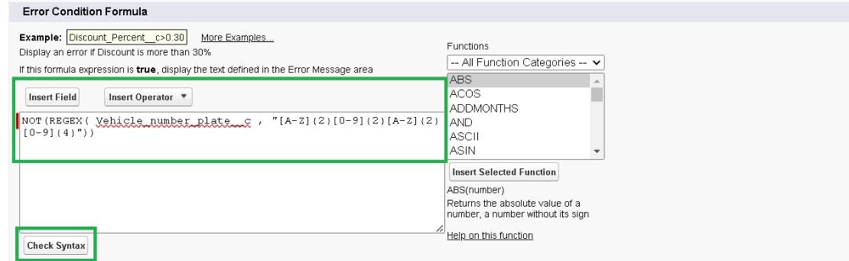

To Create A Validation Rules to an Appointment Object:

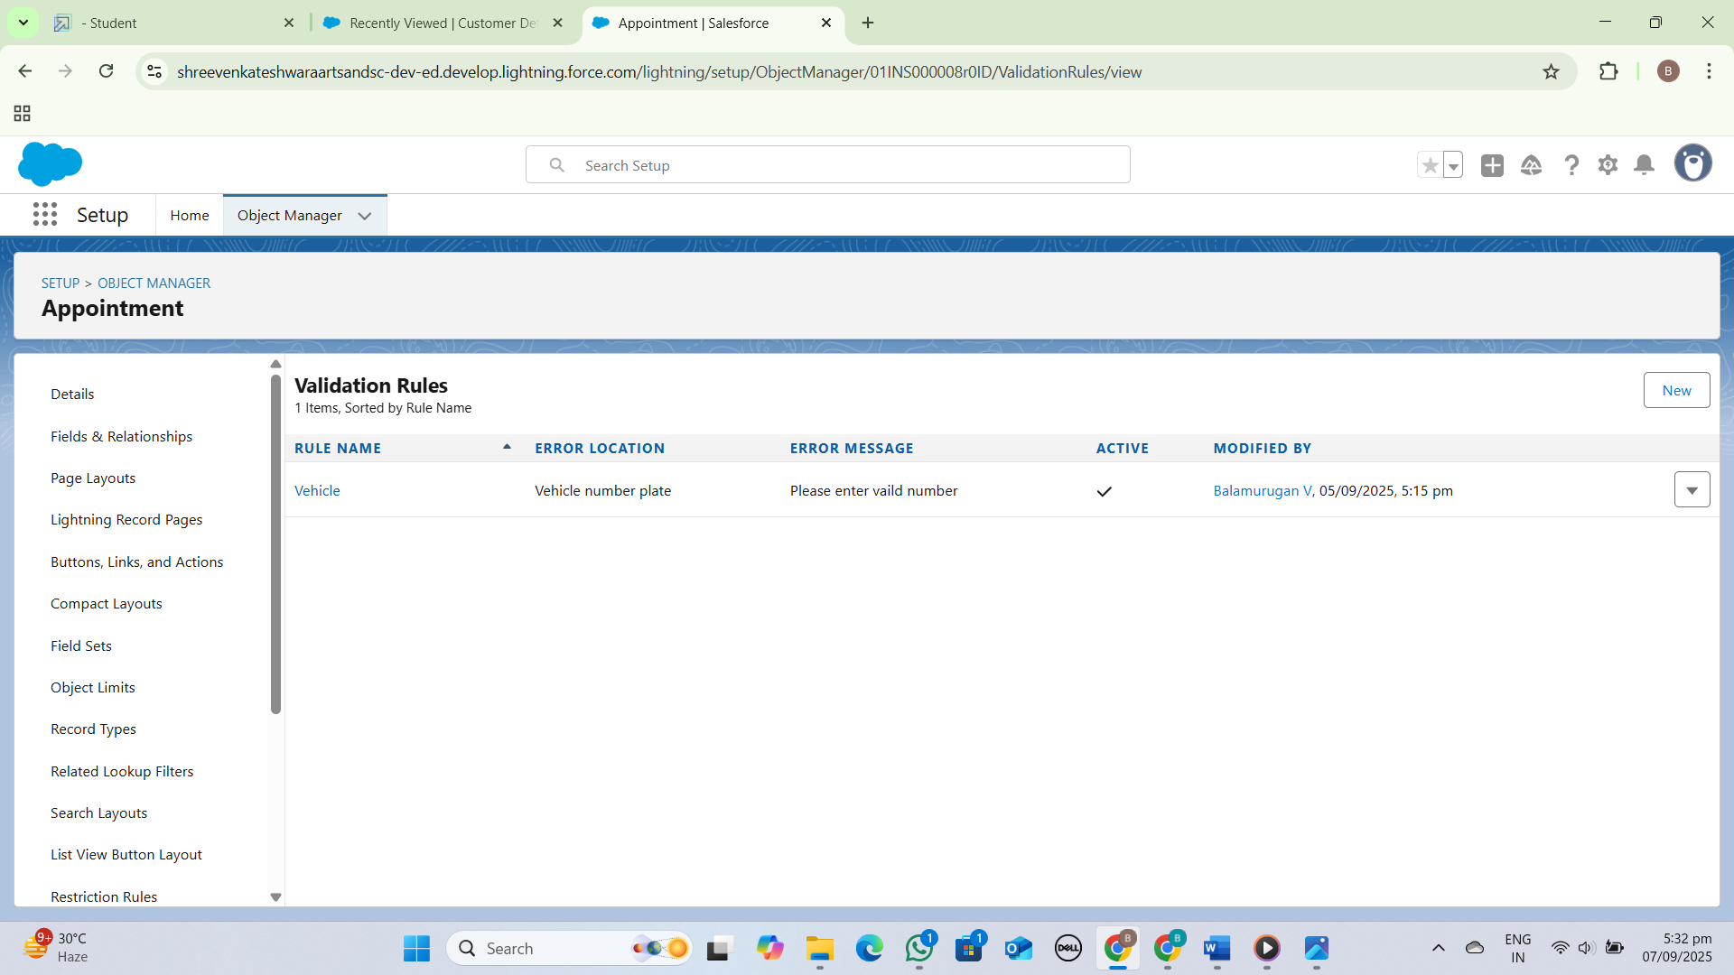

To Create a Validation Rule to a Billing Details and Feedback Object:

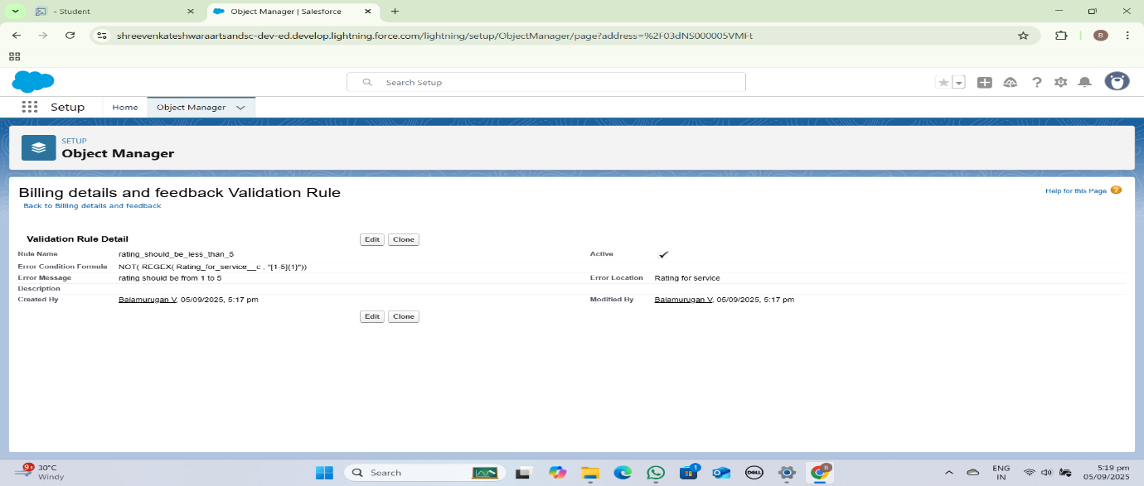

Rule Edit:

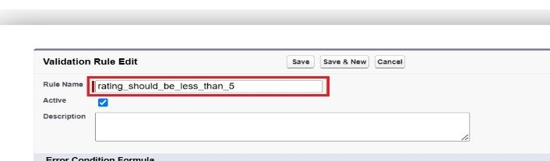

Condition Formula:

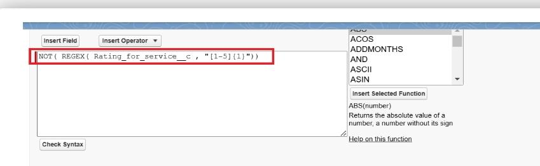

**Duplicate Rule:**

A duplicate rule in a Garage Management System (GMS) prevents *duplicate customer records* and *duplicate vehicle records*, ensuring data accuracy and integrity.

To Create a Matching Rule To an Customer Details Object

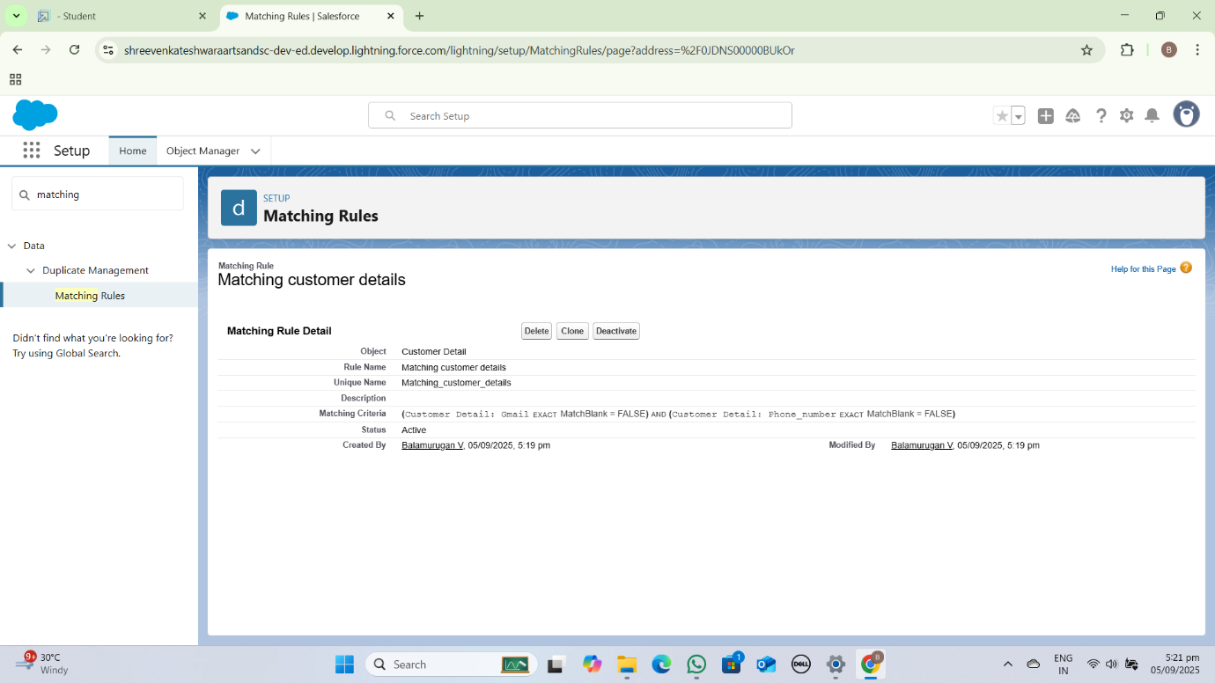

To Create a Duplicate Rule to a Customer Details Object:

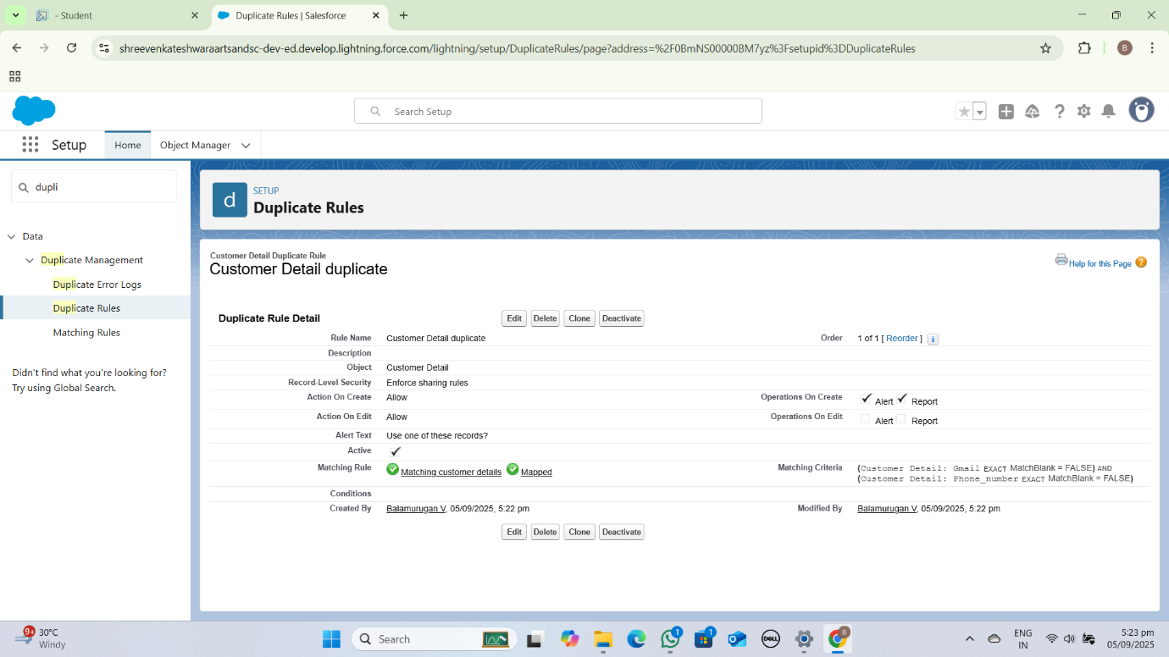

**Profiles:**

A Garage Management System (GMS) profile includes garage information, services offered, and technician details. It provides a comprehensive overview of the garage's operations and capabilities.

Manager Profile:

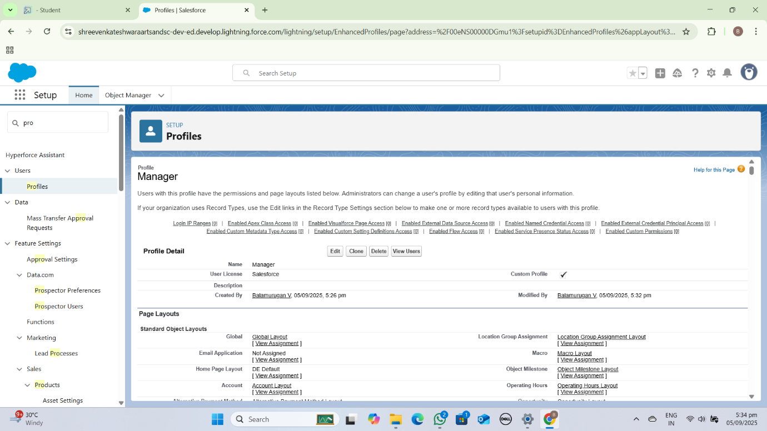

Sales Person Profile:

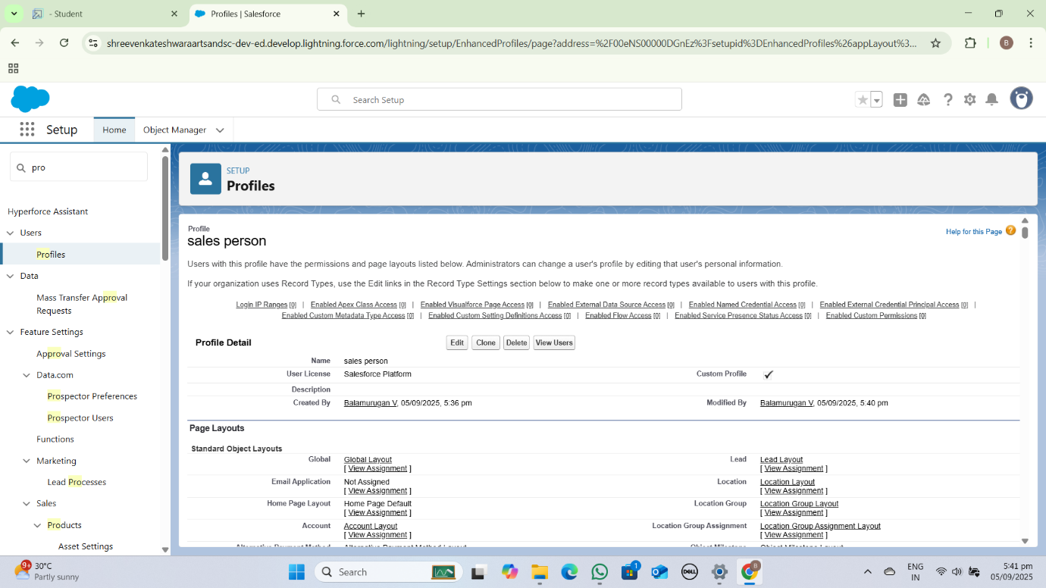

**Role & Role Hierarchy:**

In a Garage Management System (GMS), roles and role hierarchy may include:

1. *Admin*: Full access to system settings, reports, and management.

2. *Manager*: Oversees operations, manages staff, and reviews performance.

3. *Technician*: Performs vehicle services and repairs.

4. *Receptionist*: Handles customer inquiries, scheduling, and billing.

5. *Customer*: Views service history, schedules appointments**.**

**Role hierarchy:**

**1. \***Admin* > *Manager* > *Receptionist* > *Technician* > *Customer*

Creating Manager Role:

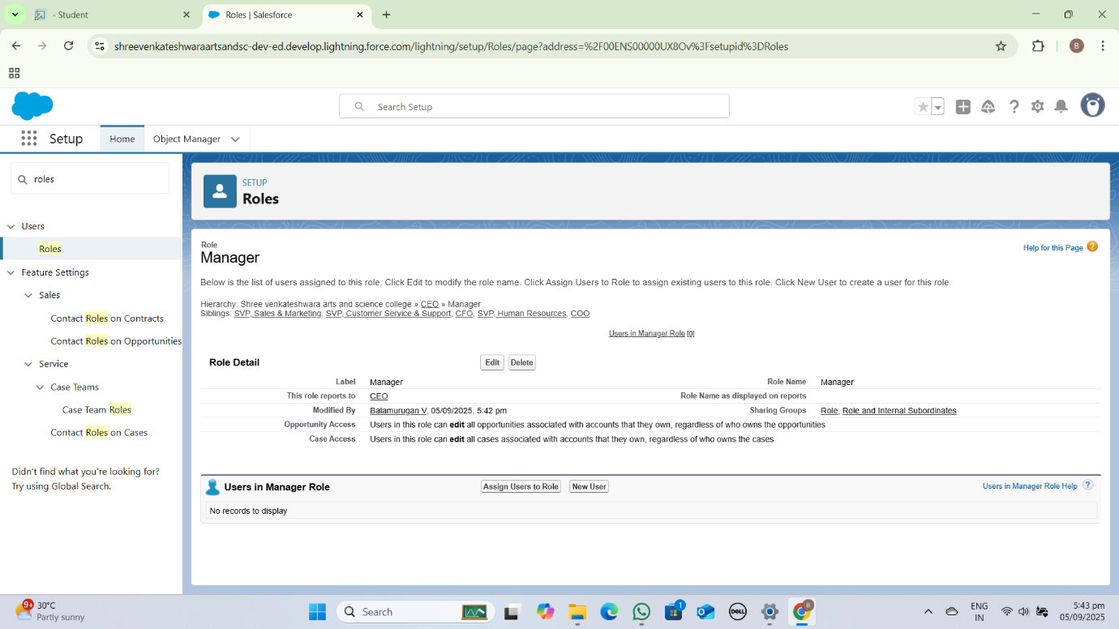

Creating Another Role:

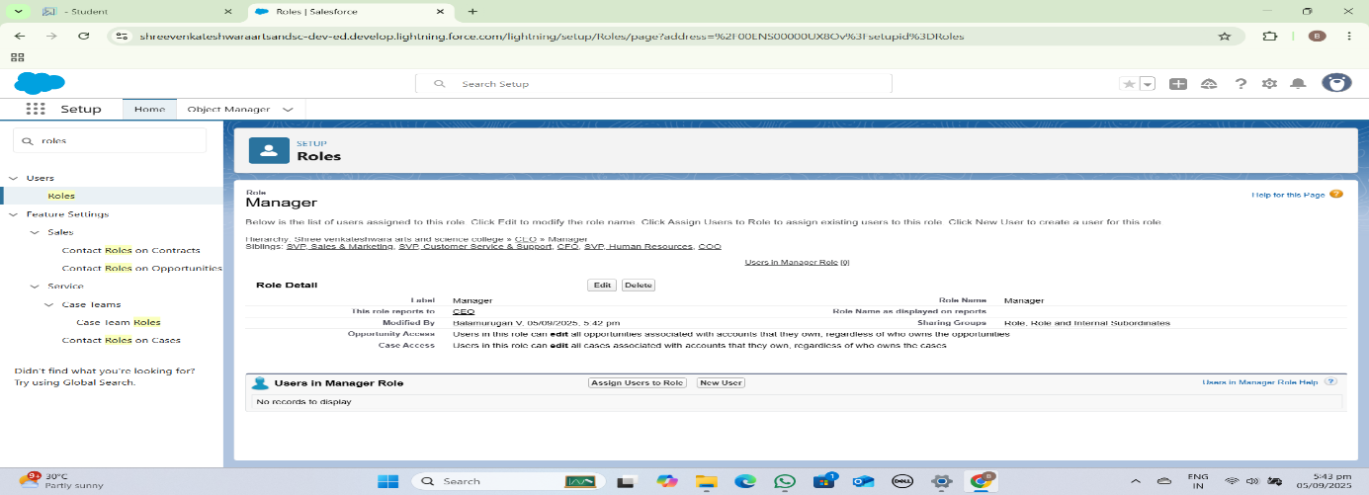

**Users:**

Create User:

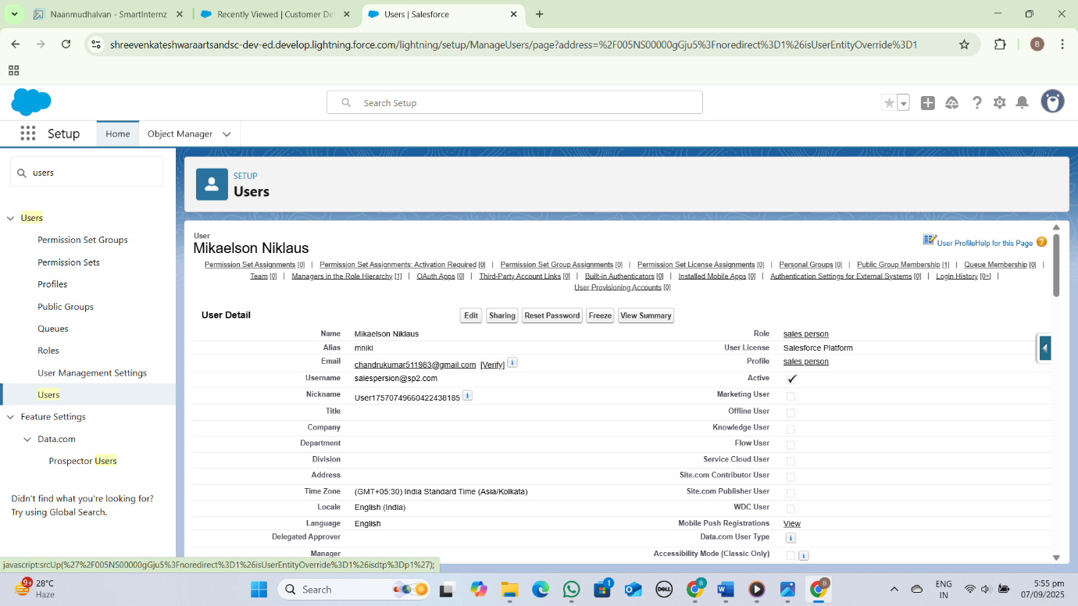

Creating Another User:

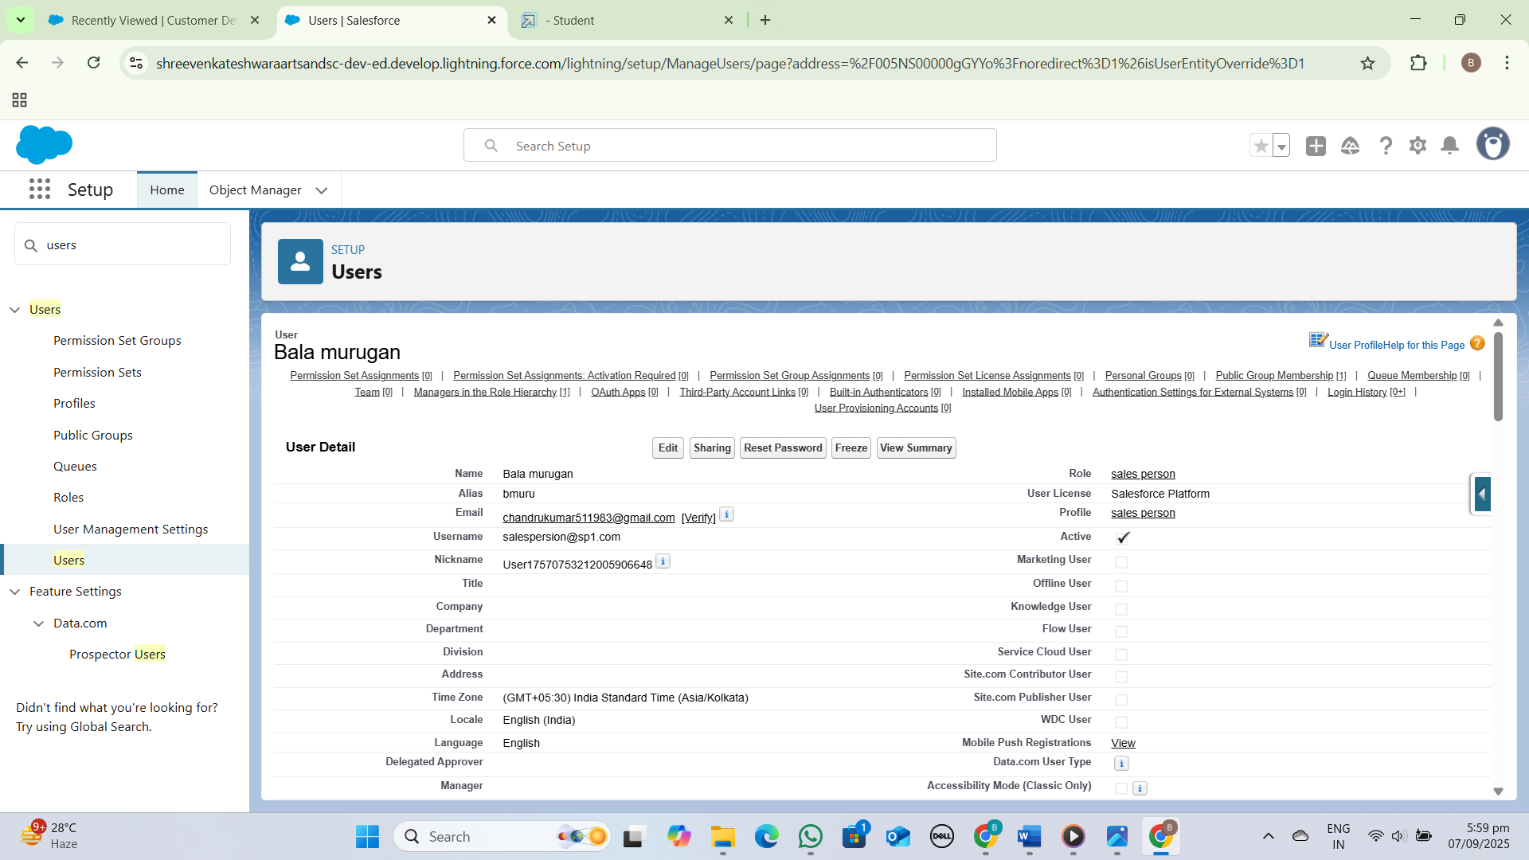

**Public Groups:**

In a Garage Management System (GMS), public groups may include *Administrators*, *Managers*, *Technicians*, and *Receptionists*. These groups define access levels and permissions for system users**.**

Creating New Public Groups:

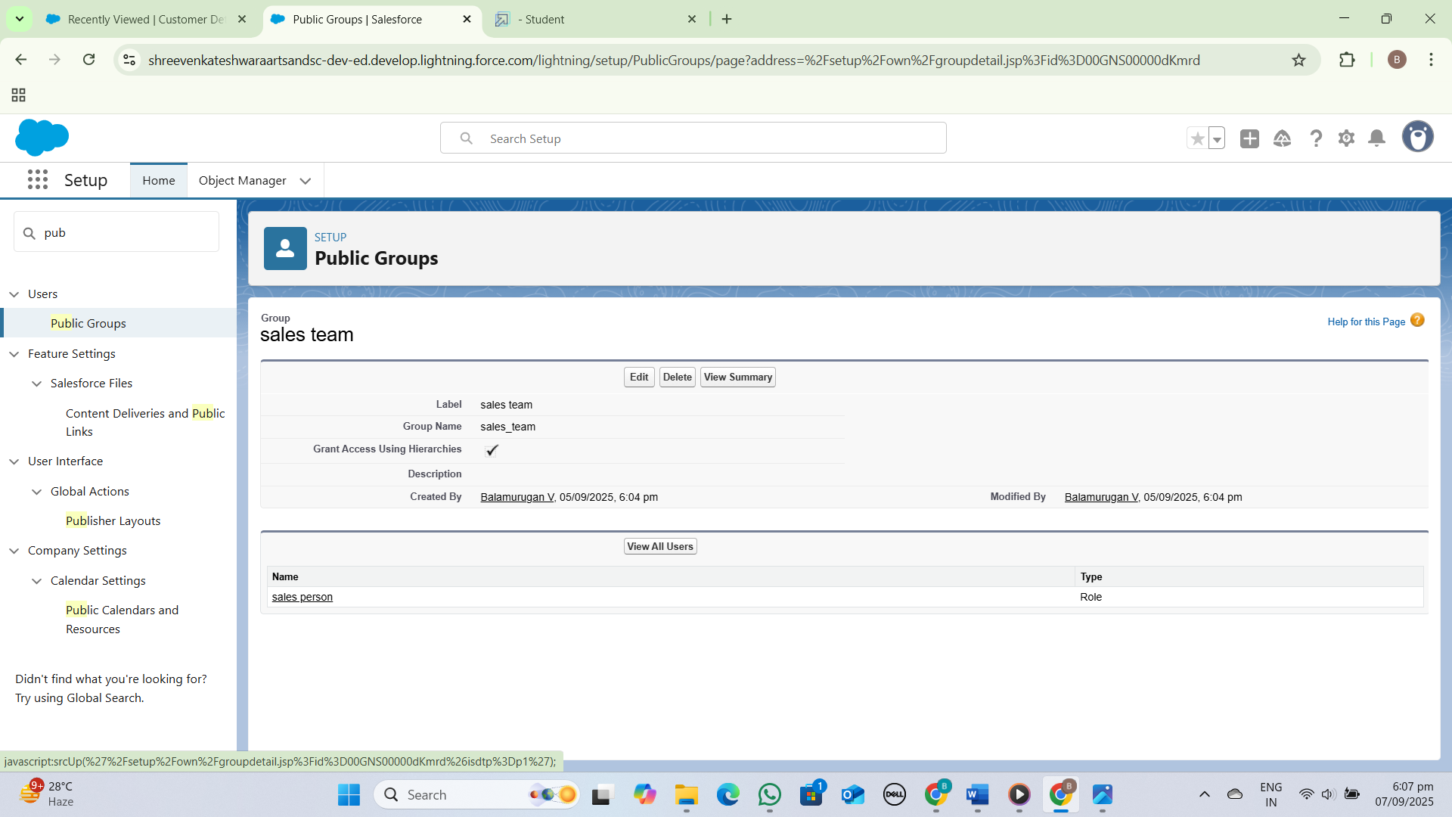

**Sharing Setting:**

Creating Sharing Settings:

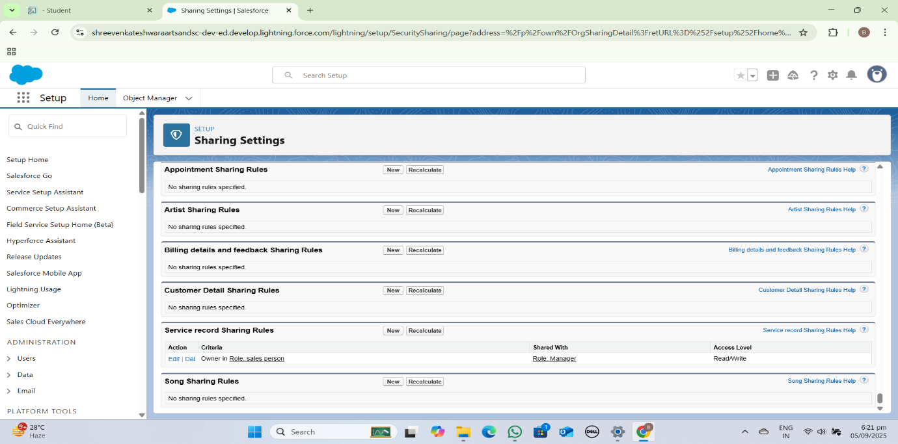

**Flows:**

In a Garage Management System (GMS), the flow typically involves *Customer Booking* and *Service Fulfillment*, where customers schedule appointments, vehicles are serviced, and payments are processed. This flow streamlines garage operations and enhances customer experience.

Create A Flow:

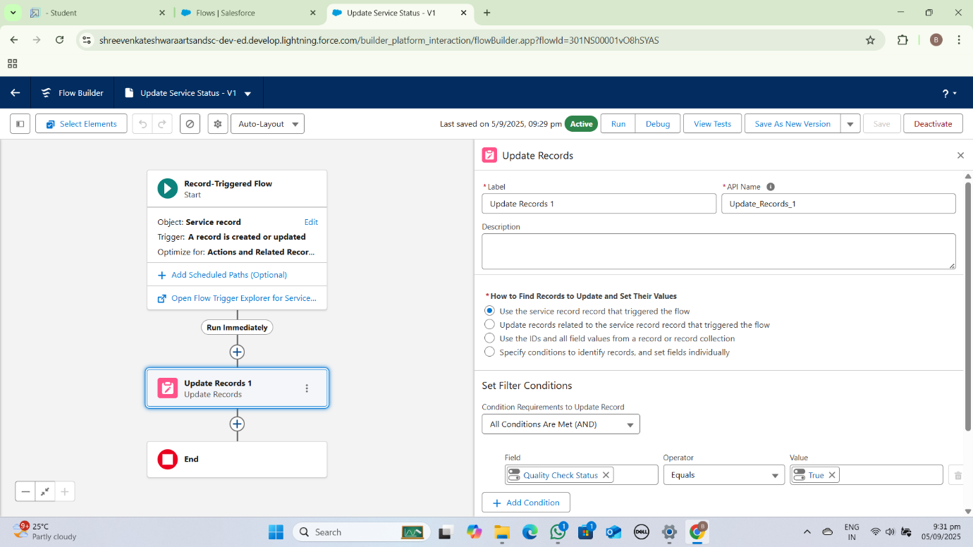

**Apex Trigger**:

In Salesforce, an Apex trigger for a Garage Management System (GMS) could be used to:

1. *Automate tasks*: Trigger actions when records are inserted, updated, or deleted.

2. *Validate data*: Ensure data consistency and accuracy.

3. *Send notifications*: Notify stakeholders of changes or updates.

Apex Handler:

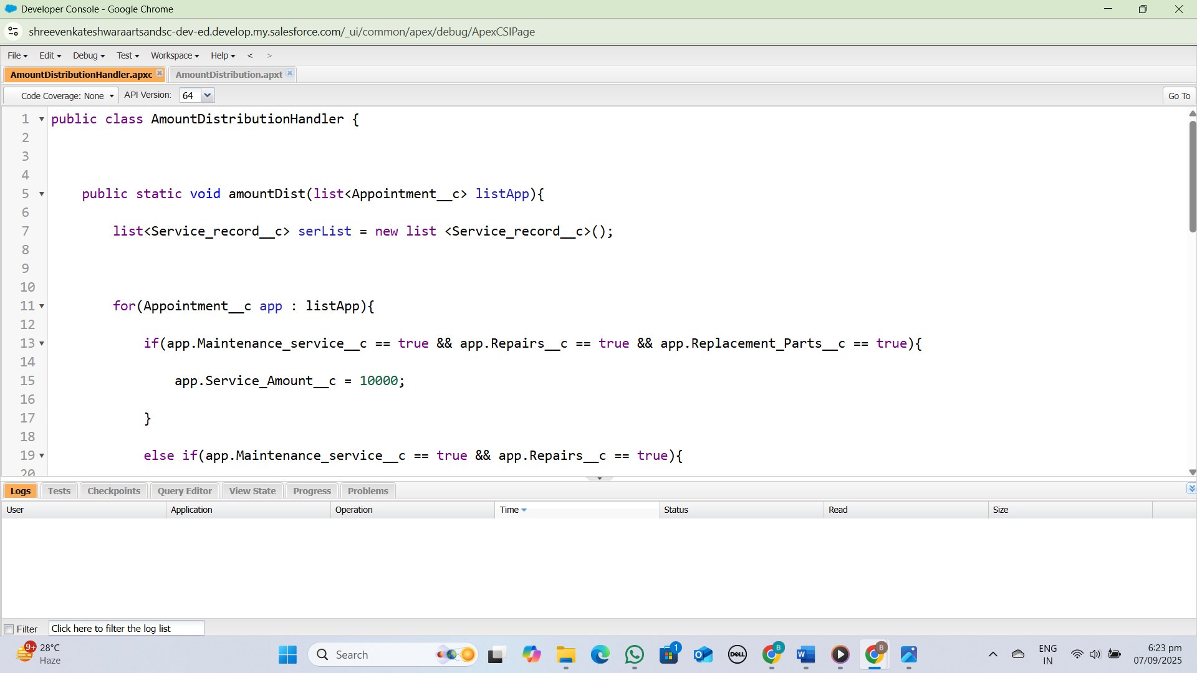

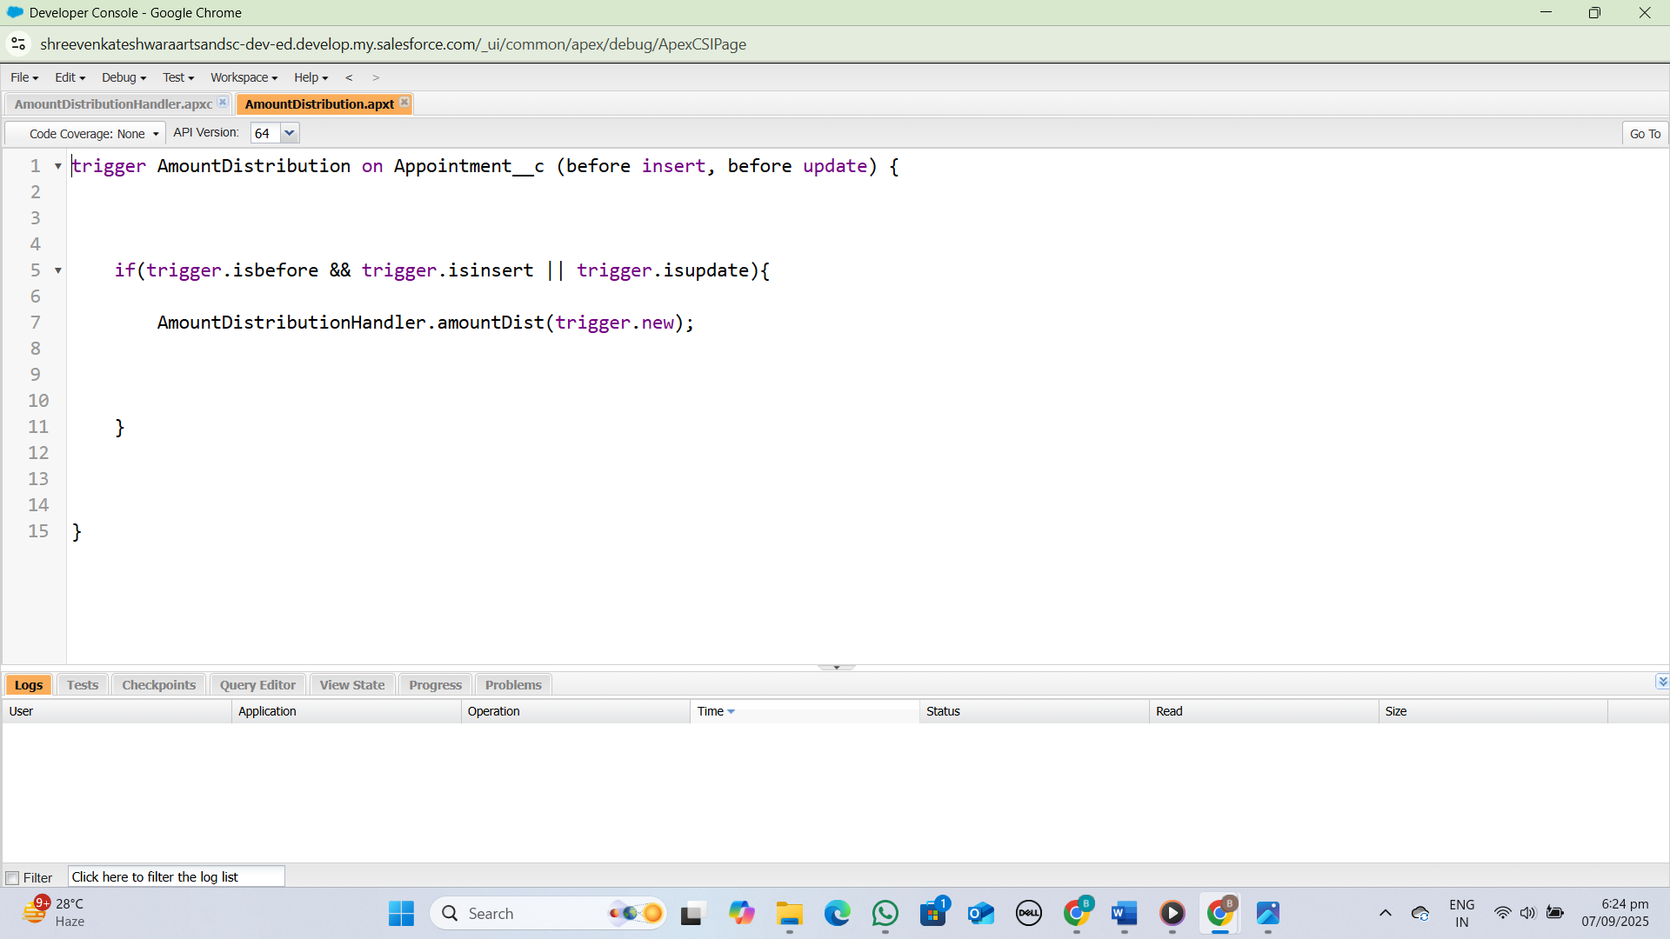

**Reports:**

A Garage Management System (GMS) generates reports on *Service History*, *Revenue*, *Inventory*, and *Technician Performance*. These reports provide valuable insights to optimize garage operations and inform business decisions**.**

Create A Report Folder:

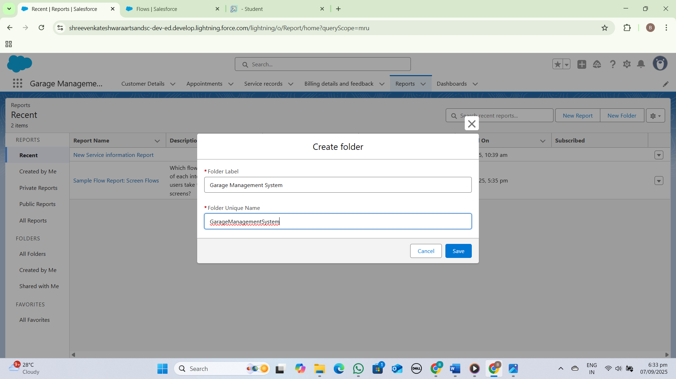

Sharing A Report Folder:

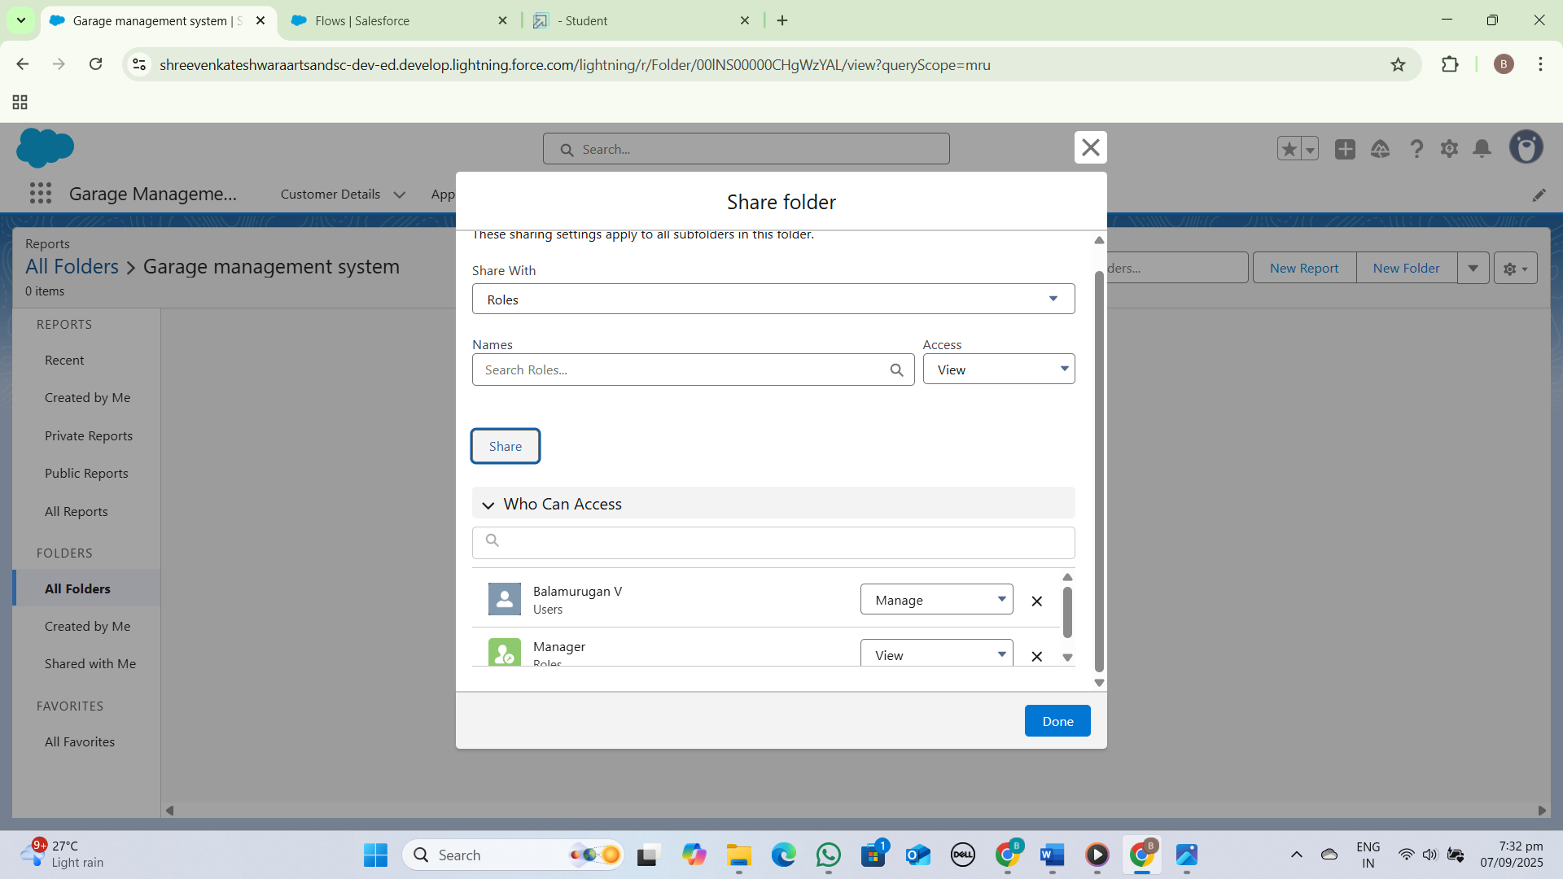

Create Report Type:

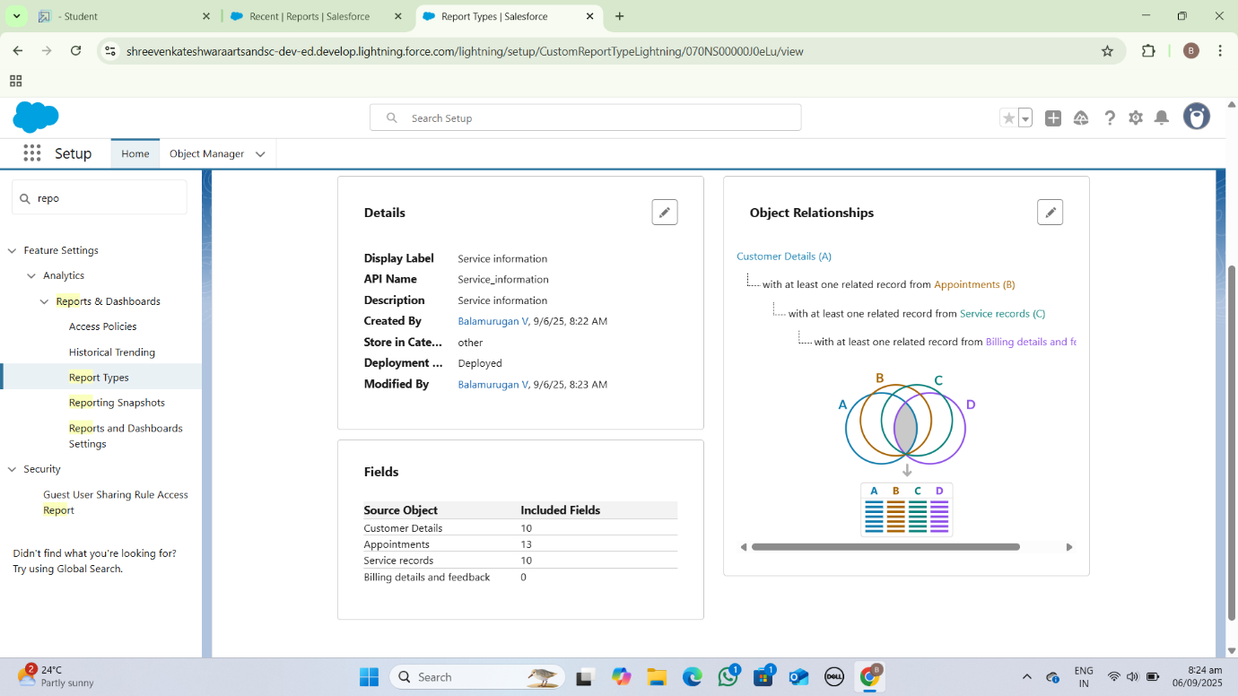

Create Report:

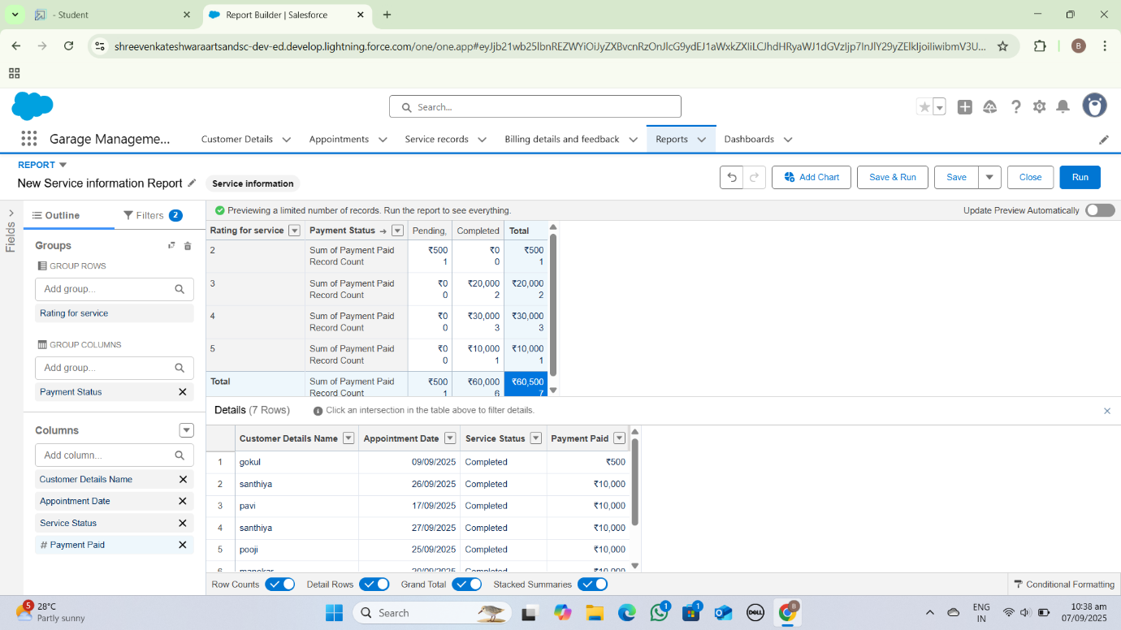

**Dashboards:**

A Garage Management System (GMS) dashboard displays key metrics like *Appointment Schedule*, *Revenue*, and *Inventory Levels*. It provides a centralized view of garage operations and performance.

Create Dashboard Folder:

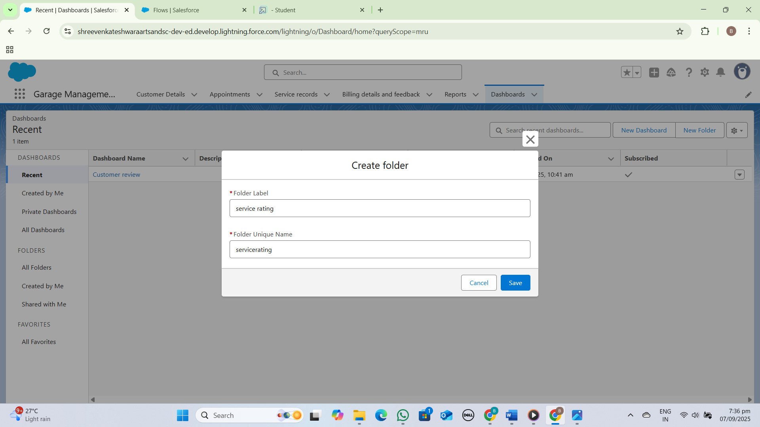

Create Dashboard:

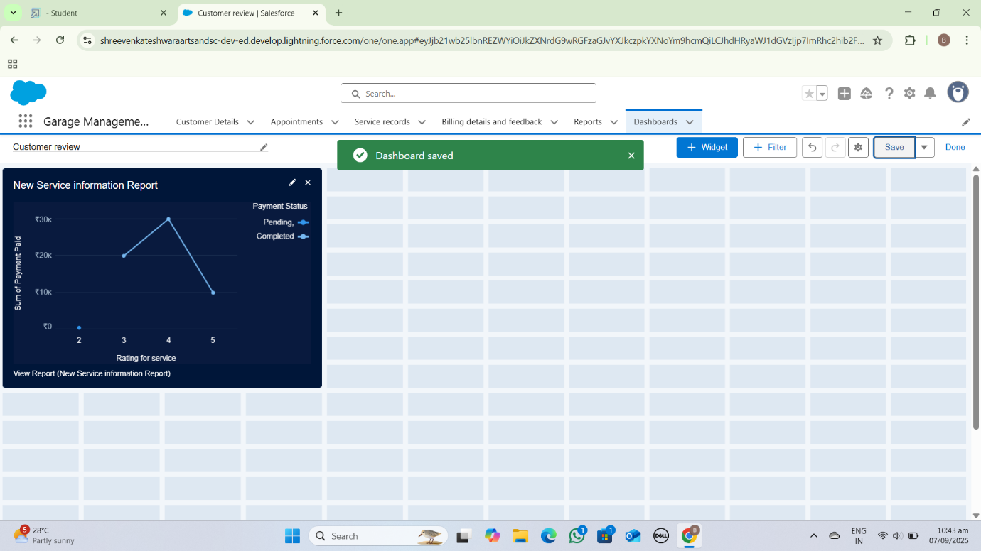

**User Adoption:**

User adoption of a Garage Management System (GMS) requires *effective training* and *ongoing support* to ensure staff can utilize the system efficiently. This leads to improved productivity and customer satisfaction.

Creating Records:

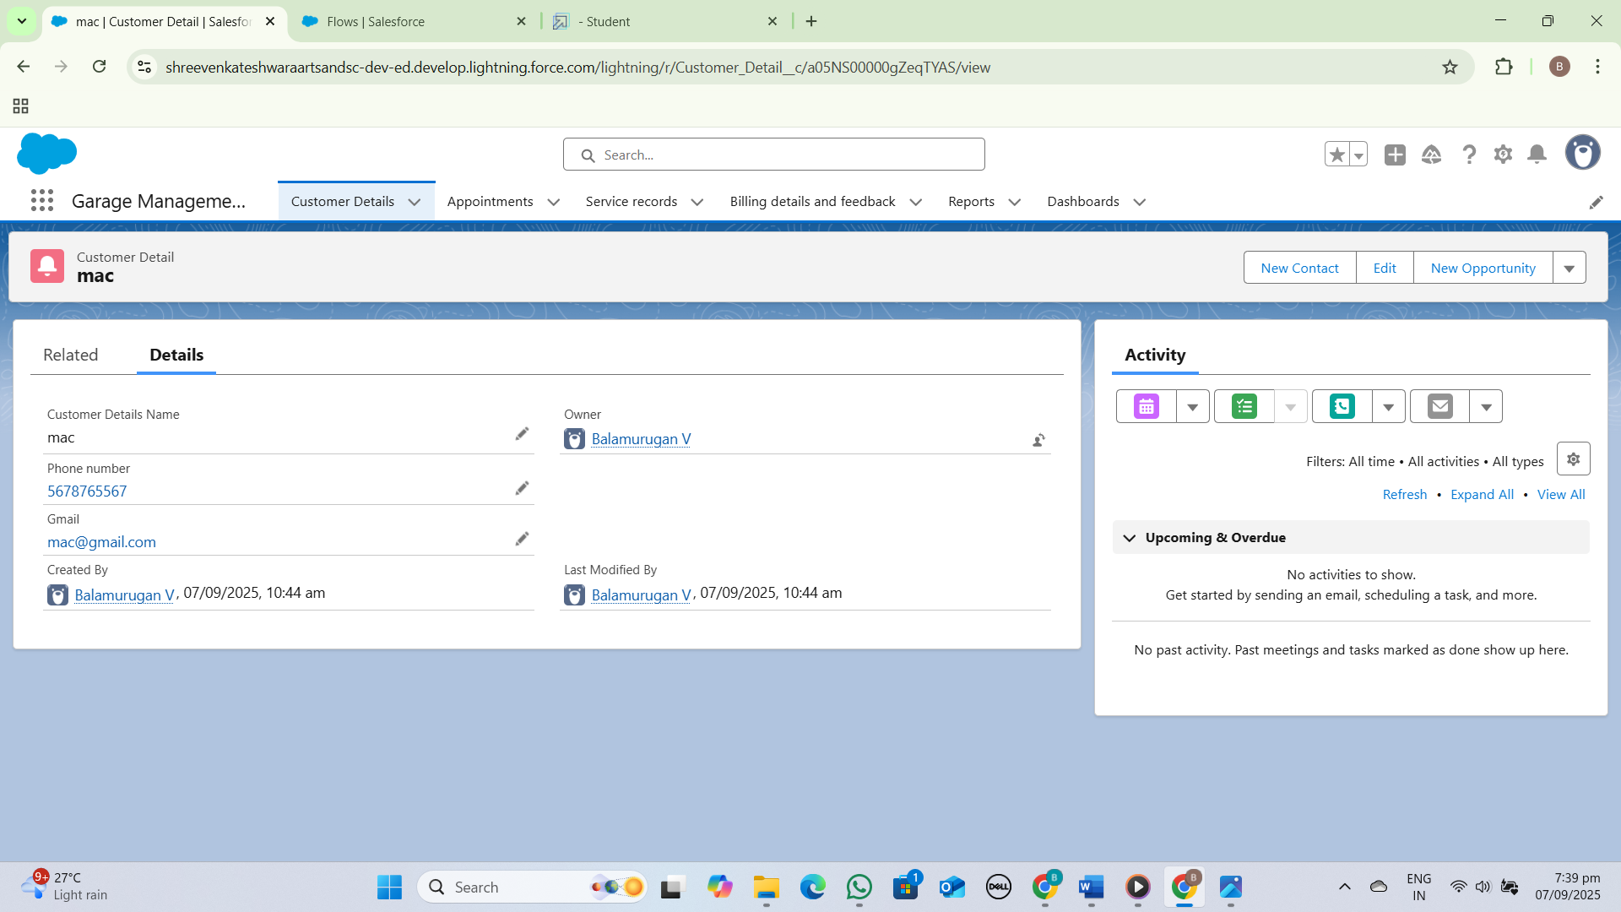

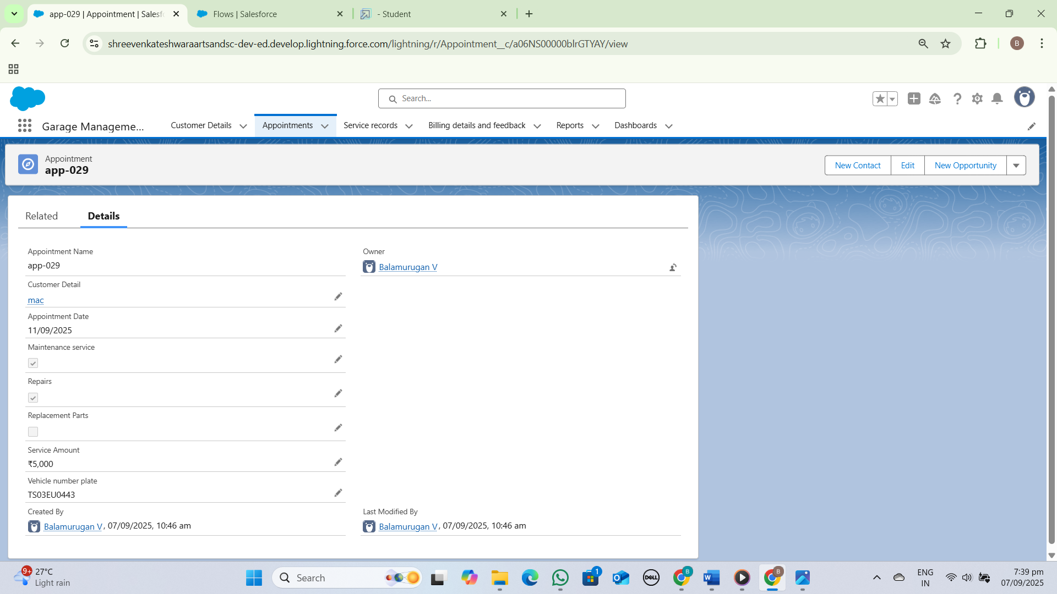

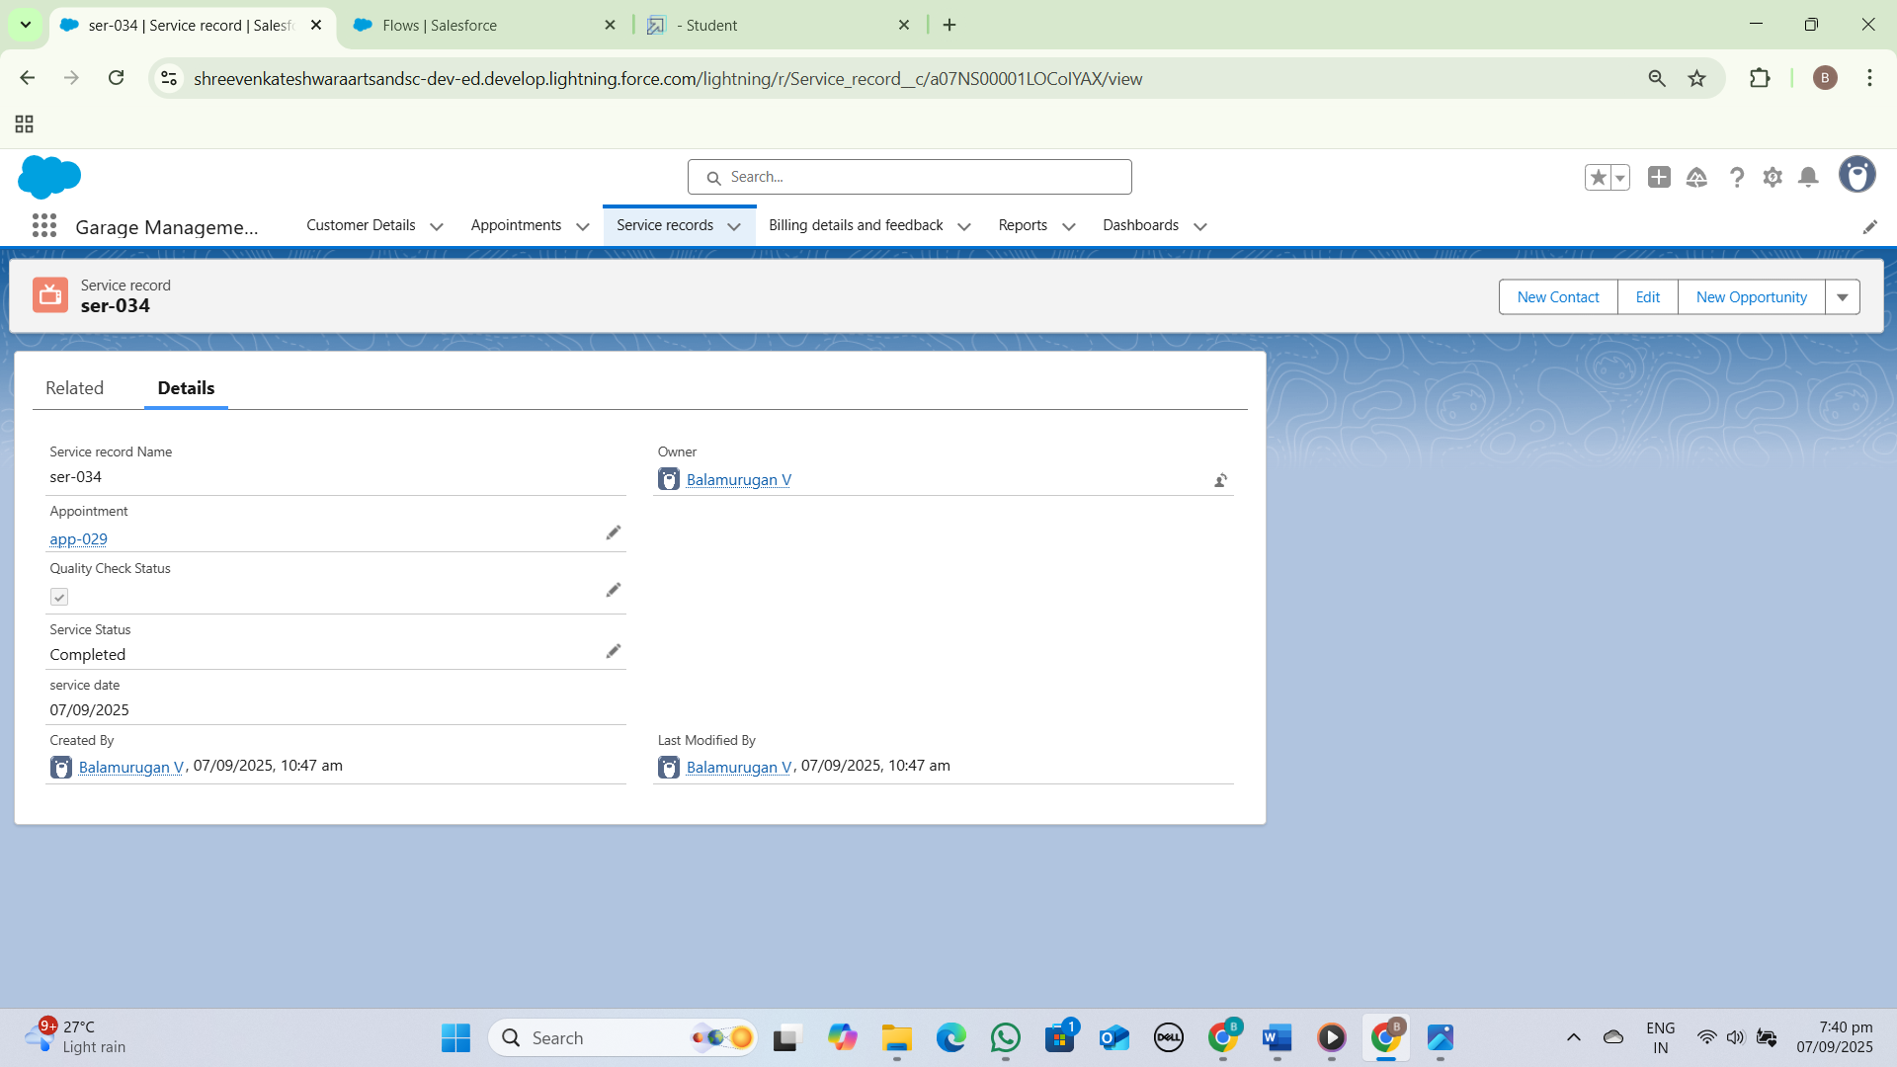

**CONCLUSION:**

The Garage Management System (GMS) plays a vital role in modernizing and streamlining the operations of automobile service centers. By automating tasks such as customer management, vehicle tracking, service scheduling, billing, and inventory control, the system reduces manual effort, minimizes errors, and saves valuable time.